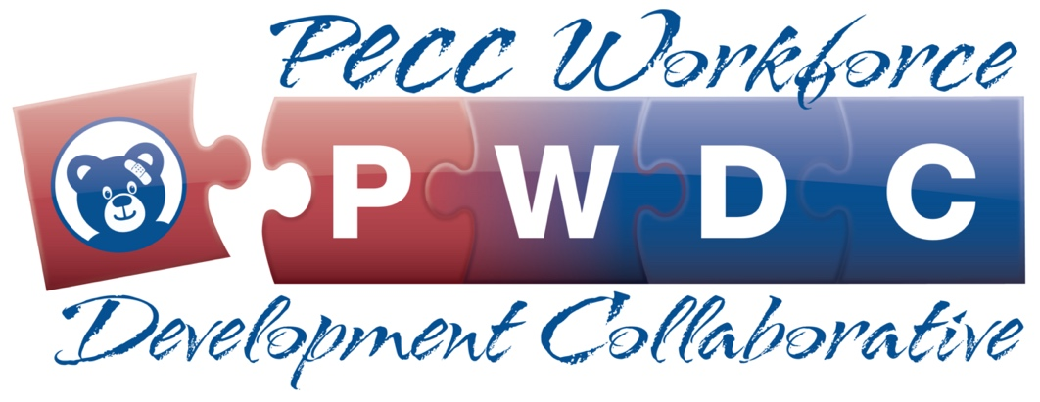

Title: Become a Pediatric Emergency Champion: Learn about the PECC Workforce Development Collaborative
Date: July 14, 2021, 2:00 – 2:30 CT
Description: Pediatric emergency care coordinators, also known as PECCs, are vital to providing quality care to children in emergency settings. The PECC Workforce Development Collaborative is a free program that will provide resources, training, and networking opportunities with specific tracks for prehospital practitioners and hospital-based providers. This 30-minute webinar will provide a detailed overview of the collaborative and give you the opportunity to have your questions answered. To learn more about the collaborative and register for the webinar, which is being offered through the EMS for Children Innovation and Improvement Center, visit: https://emscimprovement.center/collaboratives/pwdc/
Funding Disclaimer: The EMS for Children Innovation and Improvement Center is supported by the Health Resources and Services Administration (HRSA) of the U.S. Department of Health and Human Services (HHS) as part of an award (U07MC37471) totaling $3M with 0 percent financed with nongovernmental sources. The contents are those of the author(s) and do not necessarily represent the official views of, nor an endorsement, by HRSA, HHS, or the U.S. Government. For more information, please visit HRSA.gov
Dissemination plan:

-Event graphic
-Newsletter blurb
-Social media posts
-Pulse – events highlight; add to Q&A article
-Homepage highlight

