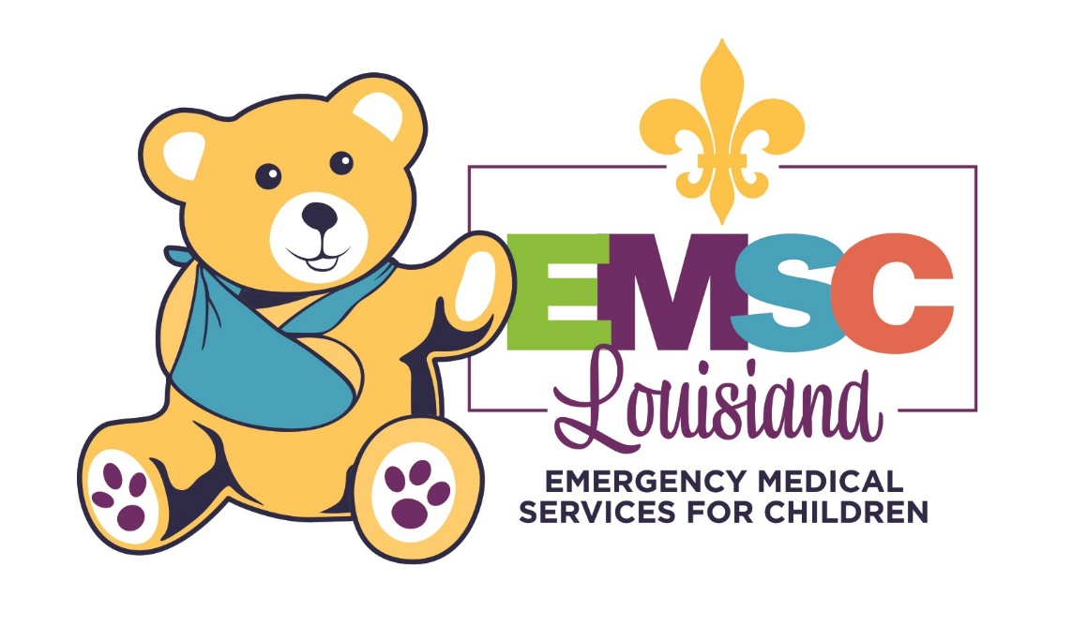
E: EMSC@LA.GOV | O: 225-342-7609 | PartnersForFamilyHealth.org/EMSC

EMS Pediatric Emergency Care Coordinator (PECC)
Role description gUIDE
This guide was created through collaboration of EMS agency leadership, medical directors, pediatric emergency physicians, established EMS PECCs, and members of the Louisiana EMS for Children Advisory Board.

Introduction
The Pediatric Emergency Care Coordinator (PECC) is a dynamic role for Louisiana EMS agencies which may encounter pediatric patients while providing emergency medical or trauma response.
Establishing at least one PECC within every first response and transporting EMS agency will enhance consistent pediatric patient care by creating a consortium of subject matter experts who work to improve health outcomes of pediatric patients who access emergency care. One agency may choose to have one or more PECCs aligned with it. Likewise, multiple agencies who have strong collaborative partnerships may elect to have the same PECC(s) represent each agency. The following scenarios are acceptable for full time or part time EMS PECCs:
- Ideal: One agency has one (or more) PECCs
- Acceptable: Multiple agencies in the same Louisiana Department of Health (LDH) region share one (or more) PECCs

Responsibilities of a Pediatric Emergency Care Coordinator (PECC)

Agencies should use this Pediatric Emergency Care Coordinator (PECC) description to identify and develop the most appropriate individual(s) for the role.

The PECC is dedicated to staying abreast of the most current evidence based and best practices in pre-hospital pediatric emergency care.
- Ensure that pediatric-specific equipment and supplies are available for each ambulance in the agency’s fleet, using national consensus recommendations as a guide.
- Verify, with assistance from the training division, that EMS providers are competent in using the pediatric-specific equipment and supplies.
- Educate EMS providers on family-centered care, including:
  - Delivering information to pediatric patients and their caregivers
  - Explaining procedures to patients and caregivers before interventions are performed
  - Allowing family members to remain present with their child
  - Implementing agency policies and procedures that allow a family member or guardian to accompany a pediatric patient during transport

The PECC understands the importance of and advocates for the EMS agency to collect and submit EMS data.
  - Collaborate with the Louisiana Emergency Response Network (LERN), which is compliant with the most current version of the National EMS Information System (NEMSIS).
  - Determine the most appropriate pediatric data to be collected and submitted by the EMS agency.
  - Maintain appropriate IT resources to ensure data collection is timely, accurate, and accessible.

The PECC has direct access to EMS leadership, including inclusion, involvement, and collaboration to advocate specifically for improving pediatric care.
This table names specific roles of EMS leadership with whom the PECC interacts. It includes examples of tasks which should be performed with each respective member of leadership.
MEDICAL DIRECTOR | OPERATIONS LEADERS
- Meet regularly to advocate for inclusion and improvement of pediatric specific patient care guidelines. | - Meet regularly to advocate for inclusion and improvement of pediatric specific policies and protocols.
TRAINING OFFICER
- Meet periodically to ensure continuity for pediatric initiatives and overall educational training objectives for EMS professionals.
- Assist in developing pediatric-specific processes for:
  - Delivering comprehensive, ongoing education
  - Evaluating psychomotor and cognitive competencies
  - Educating providers about the unique physical characteristics, physiological responses, and psychosocial needs of children with acute illness or injury
STATEWIDE PEDIATRIC EMERGENCY CARE CONSORTIUM (PECCs in other EMS agencies) |  | LA EMSC PROGRAM  (LOUISIANA EMS FOR CHILDREN)
- Collaborate with other PECCs by meeting regularly to create statewide consistency in providing quality, evidence-based pediatric emergency care by:  - Developing resources  - Exchanging ideas  - Sharing knowledge |  | - Serve as the point of contact for pediatric related research and coordinate/facilitate related activities.  - Exchange ideas and information  - Utilize resources from the EMSC program.

The PECC will maintain knowledge of pediatric capabilities within regional hospitals and destinations of care.
- Create, implement, and maintain destination protocols for pediatric patients.
  - Includes appropriate emergency departments
  - May include urgent care centers and mental-health facilities, where applicable
- Utilize the statewide EMSC Facility Recognition program* to help inform pediatric destination protocols. *Program is under development by the EMSC Board, and it will be implemented in Jan. 2021.

The PECC will serve as a liaison to patient destinations.
- Follow up with EMS providers for after-action, quality assurance reviews
- Promote pediatric emergency readiness/preparedness for the region
- When appropriate, follow up with destination facility for patient outcome reports

This publication is supported by the Health Resources and Services Administration (HRSA) of the U.S. Department of Health and Human Services (HHS) as part of an award totaling $1,300,000 with 0% financed with non-governmental sources. The contents are those of the author(s) and do not necessarily represent the official views of, nor an endorsement, by HRSA, HHS, or the U.S. Government. For more information, please visit HRSA.gov.

