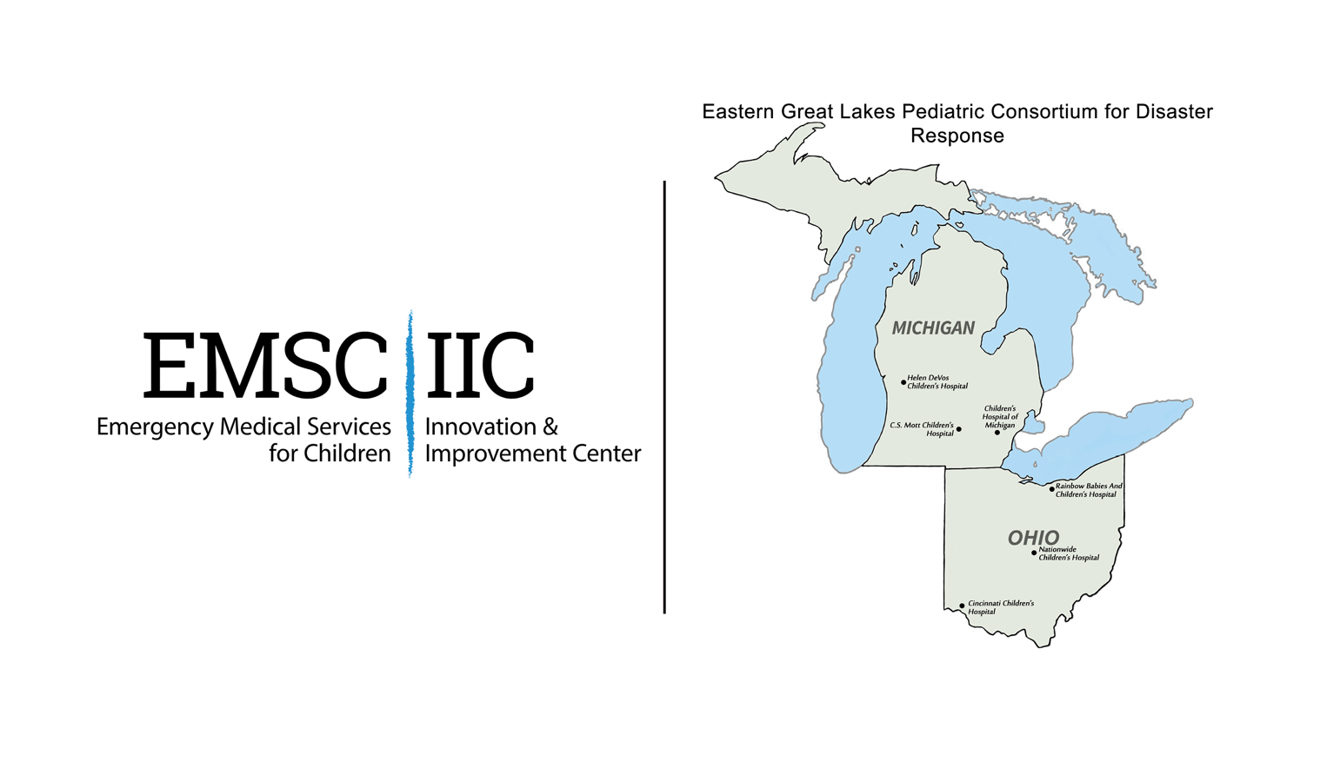

Pediatric Disaster Preparedness Quality Collaborative

Module 1: The Pediatric Champion

July 15 - 28, 2020

Module 1: Pediatric Champion

In the United States, most children who seek emergency care (83%) present to general emergency departments (EDs) and not to specialized pediatric centers. In 2007, the Institute of Medicine stated that these EDs that are not well prepared to care for children, both in terms of availability of equipment and supplies, as well as training and readiness of the ED staff.¹
A growing body of evidence—including the results of the 2013 EMSC National Pediatric Readiness Assessment—indicates that the presence of pediatric champion, also called a Pediatric Emergency Care Coordinator (PECC), is strongly correlated with enhanced pediatric readiness, independent of other factors.² Similarly, an increased score on the National Pediatric Readiness Assessment is associated with decreased mortality in critically ill children.³
A Pediatric Champion is broadly defined as an individual—physician, nurse, or other healthcare staff member—that has a desire to improve pediatric emergency care at their institution. Roles and responsibilities of the pediatric champion are detailed in the 2018 Joint Policy Statement, “Pediatric Readiness in the Emergency Department” put forth by the American Academy of Pediatrics (AAP), American College of Emergency Physicians (ACEP) and the Emergency Nurses Association (ENA). An outline of the physician and nurse pediatric champion’s responsibilities can be found in the EIIC’s Readiness toolkit here and here. However, in general the Pediatric Champion is responsible for ensuring the following:
- Availability of essential pediatric supplies and equipment
- Adequate training of staff on the use of equipment in line with the emergency care and resuscitation of infants and children
- Ensuring ED policies and procedures consider the needs of children of all ages
- Facilitate the integration of pediatric needs in hospital disaster and/or emergency preparedness plans and promoting the inclusion of pediatric patients in disaster drills
For adult-focused emergency departments, a comprehensive hospital disaster plan that includes the needs of children and families requires the identification of a committed pediatric representative to lead the cooperative effort among hospital departments, personnel and leadership. Working in concert with the Hospital Disaster Coordinator, the pediatric champion assures pediatric considerations and priorities are integrated into the disaster plan as well as into all staff disaster education and training. Using an all-hazards approach, the disaster plan integrates the unique needs and responses of the pediatric patient. Pre-planning inventory of available resources and access to pediatric specific equipment and professionals should also be part of the disaster plan.
The role of the pediatric champion as it relates to disaster preparedness at a children’s hospital is somewhat different. Presumably, the disaster plans at these hospitals is entirely devoted to pediatric-specific disaster needs. Instead of titling this person a Pediatric Champion, this person will be more of a Disaster Champion who brings clinical leadership and disaster expertise to the committee as well as champions outreach activities or educational opportunities for non-pediatric hospitals in the region.

Tasks
The purpose of the following tasks is to guide you as you explore the degree to which pediatrics is represented in your hospital disaster management.

Please complete these tasks/questions in REDCap here: https://redcap.dellmed.utexas.edu/surveys/?s=H8NKFRWRXM

- Determine who your hospital Emergency Manager is and collect their contact information (Name, Credentials, Title, Email, Phone)
- Do you have an emergency management committee? (Y/N)
- If no, why do you not have an emergency management committee and are there plans to form one?
- If yes, is there clinical pediatric expertise on the committee? (Y/N)
- If yes, please describe her level of pediatric expertise.
- Does this person have any formal training in pediatric disaster management?
- Is this person formally part of the committee structure or carry a formal title related to pediatric disaster coordination? (Y/N)
- If no, why is this person not a formal member of the committee?
- What change strategies do you plan to use to improve in this area?

Change Strategies

- Identify an individual with expertise and/or interest in pediatrics and disaster planning
The individual may be a member of care team (physician, nurse, nurse practitioner).

- Define the Pediatric Champion’s role and responsibilities both in general, and as it relates to disaster planning*. The pediatric champion’s responsibilities can include:
  - Incorporates pediatric-specific considerations within the hazard vulnerability analysis and planning goals
  - Plans and coordinates disaster drills that include pediatric patients
  - Serves as liaison for pediatric patients/concerns on hospital committees (e.g., medical, trauma, disaster, etc.)
  - Assures pediatric considerations and priorities are included in all staff disaster education and training
  - Assures pediatric considerations and priorities are included in disaster education for prehospital providers
  - Assists with development and review of the hospital disaster policies, ensuring that pediatric needs are addressed
  - Serves as liaison representing children to regional facilities, EMS agencies, healthcare coalitions, and organizations to promote community disaster preparedness inclusive of children
  - Collaborates with disaster program manager
  - Promotes pediatric disaster awareness in the community
*We encourage the recruitment of the hospital emergency manager to help define these responsibilities.

- Garner support from ED and Hospital Leadership to formalize the role with a defined title, responsibilities and authority. We have put together the following tip sheet in the appendix on the importance on including pediatric considerations in the hospital disaster preparedness plan.

- Identify educational opportunities for the pediatric champion to enhance their foundational knowledge of the needs of children and families during catastrophic events. A list of training courses can be found on the EIIC’s website here: https://emscimprovement.center/education-and-resources/toolkits/pediatric-disaster-preparedness-toolbox/. However, we recommend the
FEMA 439 Hospital Emergency Response Training

- Develop a training program for the care team on the hospital disaster policy as it relates to pediatric-specific disaster needs.
  - Identify training delivery modality (e.g., online, in-person staff meetings, peer to peer)
  - Inform members of care team about the role and responsibilities of the pediatric champion

Children’s Hospitals
- Work to ensure clinical leadership with disaster expertise is a member of the committee (e.g. medical director of emergency management) and then establish a formal leadership role on the committee.

- Develop an outreach program for non-children’s hospitals in your region to provide education and training on the needs of children in disaster.

References and Further Reading

- Institute of Medicine. 2007. Emergency Care for Children: Growing Pains. Washington, DC: The National Academies Press.

- Gausche-Hill M, Ely M, Schmuhl P, Telford R, Remick K, Edgerton E, Olson L. National Assessment of Pediatric Readiness of Emergency Departments. JAMA Pediatrics. 2015 Jun; 169(6): 527-34.

- Ames SG, Davis BG, Marin JR, Fink EL, Olson LM, Gausche-Hill M, Kahn, JM. Emergency Department Pediatric Readiness and Mortality in Critically Ill Children. Pediatrics September 2019, 144 (3) e20190568; DOI: https://doi.org/10.1542/peds.2019-0568

- Remick K, Gausche-Hill M, Joseph MM, Brown K, Snow SK, Wright JL; American Academy of Pediatrics Committee on Pediatric Emergency medicine and Section on Surgery; American College of Emergency Physicians Pediatric Emergency Medicine Committee; Emergency Nurses Association Pediatric Committee. Pediatric Readiness in the Emergency Department. Pediatrics. 2018;142(5):e20182459

- Barfield WD, Krug SE, Kanter RK, et al. Task Force for Pediatric Emergency Mass Critical Care. Neonatal and pediatric regionalized systems in pediatric emergency mass critical care. Pediatr Crit Care Med. 2011;12:S128–34

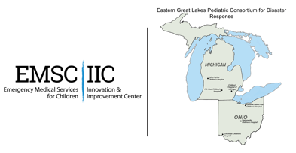
Appendix I: Inclusion of Pediatrics in Hospital Disaster Plans
Tips and Talking Points for Hospital Leadership
July 2020

Defining the Need
- In the United States, most children who seek emergency care (83%) present to general EDs versus specialized pediatric emergency departments (EDs).

- Children are disproportionately impacted during a disaster owing to their unique physical characteristics, developmental ability and limited capacity to understand the nature of a disaster.¹

- Man-made disasters (i.e. mass-casualty incidents) can occur anywhere, at any time, and many times involve school children.

- According to the results of the 2013 National Pediatric Readiness Assessment, only 47 percent of respondents had a disaster plan that addresses issues specific to the care of children.²

- In 2015, hospitals only met 21% of the recommendations outlined in the National Commission on Children and Disasters 2010 report.³

- Data reported by the CDC in 2008 indicated a national problem with tracking, protecting, and reunifying unaccompanied children.⁴

- Funding limitation within existing systems to address known gaps and paucity of subject matter experts (SMEs) on pediatric preparedness reduces local knowledge sharing in a region.

- Although some public health disaster response system networks and registries do exist, participation by pediatric focused practitioners is limited.

Making the Business Case
- Federal/State/Hospital mandate. Examples include:

Emergency Preparedness Requirements for Medicare and Medicaid Participating Providers and Suppliers (CMS EP Rule). Click here
  - CMS Emergency Preparedness Rule. Click here
  - The development of a Pediatric Surge Annex is a requirement of the 2019-2023 Hospital Preparedness Program (HPP) funding award.
  - Joint Commission: Emergency Management. Click here

- Identify examples of recent disasters in your area that affected children

- Marketing Potential
Share pediatric volumes and how that compares to hospitals in your region. Can your work on improving the hospital’s pediatric readiness be used to drive non-disaster related traffic and/or physician referrals?

- Tell a story
Perform chart reviews of pediatric visits. Can you find an example of a small pediatric surge and evidence on how it was handled? Or, has there been a safety issue involving a pediatric patient (i.e. dosing error, missed diagnoses) and is it reasonable to assume these mistakes might occur again if faced with a sudden influx of pediatric patients?
  - Example Elevator Pitch
  - PEM Playbook Podcast, “Zen and the Art of Pediatric Readiness.” https://pemplaybook.libsyn.com/zen-and-the-art-of-pediatric-readiness

- Share anecdotal or even formal survey results from hospital staff on their level of confidence in caring for pediatric patients.

- Take the National Pediatric Readiness Assessment and show how your hospital compares to the national average.
NOTE: Unfortunately, the assessment has been temporarily closed and will be available beginning in June 2021. In the meantime, you can complete the PedsReady hospital checklist available at the end of this packet.

Available Tools and Support

- The American Academy of Pediatrics (AAP), the American College of Emergency Physicians (ACEP), the Emergency Nurses Association (ENA) and the Health Resources and Service Administration’s Emergency Medical Services for Children (EMSC) Program are dedicated to continuing to promote the best emergency medical care for children. Physicians and nurses providing pediatric emergency care are dedicated to continuously improving the quality of that care.

- The ASPR Topic Collection: Pediatric/Children contains a wealth of resources related to pediatric disaster planning.

- The AAP has created a new Council on Disaster Preparedness and Recovery replacing the former Disaster Preparedness Advisory Council, and in partnership with the EIIC has connected EMSC State Partnership Programs with AAP chapters, both of which work at the state level to increase the ability of our emergency systems to receive and treat children in a disaster.

- The EIIC has partnered with Ohio and Michigan experts to be awarded one of the nation’s only two ASPR supported Pediatric Disaster Centers of Excellence, creating new models for the future of a national effort to support pediatric disaster preparedness and recovery. This includes co-sponsoring the Pediatric Disaster Preparedness Quality Collaborative (PDPQC).

- The EIIC has developed and maintains a Pediatric Disaster Preparedness Toolkit which serves to aid emergency department and administrative leaders (for example, a job description for a PECC coordinator and training resources) in facilitating their pediatric disaster preparedness efforts.

- The “Checklist of Essential Pediatric Domains and Considerations for Every Hospital’s Disaster Preparedness Policies” was developed by national subject matter experts and provides a detailed framework for pediatric disaster preparedness.

- EMSC State Partnership grantees are working with hospitals in their states and providing resources to assist in improving pediatric disaster preparedness. Find contact information for your local EMSC State Partnership here.

References
1. Ensuring the Health of Children in Disasters. Disaster Preparedness Advisory Council, Committee on Pediatric Emergency Medicine. Pediatrics Nov 2015, 136 (5) e1407-e1417; DOI: 10.1542/peds.2015-3112

2. National Commission on Children and Disasters. 2010 Report to the President and Congress. AHRQ Publication No. 10-M037. Rockville, MD: Agency for Healthcare Research and Quality. October 2010. https://archive.ahrq.gov/prep/nccdreport/nccdreport.pdf

3. Save the Children. Still at Risk: U.S. Children 10 Years After Hurricane Katrina. 2015 National Report Card on Protecting Children in Disasters. 2015. https://rems.ed.gov/docs/DisasterReport_2015.pdf.

4. Niska RW, Shimizu IM. Hospital preparedness for emergency response: United States, 2008. Natl Health Stat Report. 2011(37):1-14.

5. Lyle KC, Milton J, Fagbuyi D, et al. Pediatric disaster preparedness and response and the nation's children's hospitals. Am J Disaster Med. 2015;10(2):83-91.

6. Thompson T, Lyle K, Mullins SH, Dick R, Graham J. A state survey of emergency department preparedness for the care of children in a mass casualty event. Am J Disaster Med. 2009;4(4):227-232.

