ED 101
Medical Center
January 2013
Director, Emergency
Services
April 2011
X
Dana Toudouze, RN, MBA
Kimberly Aaron, MD
Teresa Clark, RN, MS HCA, CPON

Subject:  Triage of Patients  Core  General |  |  | Section:  Emergency  Department | Policy Number: |  | Page:  1 of 6
 |  |  | Application: |  | Date of Issue:
 |  |  | Contact Person: |  | Supersedes:
Recommended:  Director, Emergency Services |  |  | Approved:  Medical Director, Emergency Services  Vice President
Review:

Initial/Date

PURPOSE: To facilitate the appropriate initial prioritization and intervention for patients who present to the ED.

POLICY: All patients who present to the ED for care will be triaged.

PROCEDURE: Initial Triage is performed on arrival, using the Pediatric

Assessment Triangle

General appearance

“Si

o
k”?
c
“Si
er”

kest
?
ck
?
“Si
c
”?

er”

est

W rk of

breathing
Circulation

ED 101

Based on the findings of Initial Triage and using the triage chart below, the
Initial Triage score is documented in the patient record.

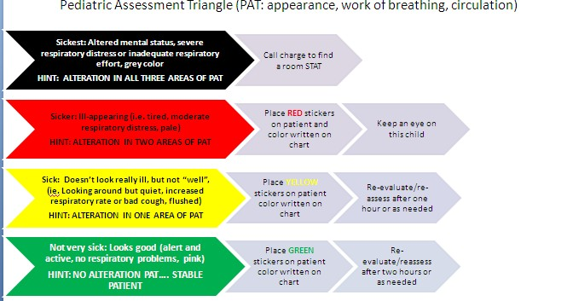

Nurse Triage Assessment- The Nurse Triage assessment is performed using the Emergency
Severity Index.

ESI Triage Algorithm

Requires immediate A Life-saving intervention?

no
High risk situation? B

or confused/lethargic/disoriented or
yes
1

yes

C 2

How many different resources are needed?

None One Many

Danger Zone
5 4 Vitals?

Refer to Cook Children’s Vital Sign Policy

Consider

ED 101

3

ED 101

Notes:

A. Immediate life-saving intervention required: airway, emergency medications, or other hemodynamic interventions (IV, supplemental O2, monitor, ECG or labs DO NOT count); and/or any of the following clinical conditions: intubated, apneic, pulseless, severe respiratory distress, SPO2<90, acute mental status changes, or unresponsive.

Unresponsiveness is defined as a patient that is either:

1. Nonverbal and not following commands (acutely); or

2. Requires noxious stimulus (P or U on AVPU scale).

B. High risk: is a patient you would put in your last bed.

Severe pain/distress is determined by clinical observation and/or patient rating of greater than or equal to 7 out of 0-10 pain scale

C. Resources; Count the number of different types of resources, not the individual tests or x-rays (examples: CBC, electrolytes and coags equals one resource; CBC plus chest x-ray equals two resources).

Resources | Not Resources
• Labs (blood, urine)  • ECG, x-rays  • CT, MRI, Ultrasound | • History & physical (including pelvic)  • Point-of-care-testing
• IV fluids (hydration) | • Saline or heplock
• IV or IM or nebulized medications | • PO medications  • Tetanus immunization  • Prescription refills
• Specialty consultation | • Phone call to PCP
• Simple procedure = 1  (lac repair, Foley cath)  • Complex procedure = 2 (conscious sedation) | • Simple wound care  (dressings, recheck)  • Crutches, splints, slings

ED 101

D. Danger Zone Vital Signs

Consider up-triage to ESI 2 if any vital sign criterion is exceeded

Pediatric Fever Considerations

1 to 60 days of age: assign at least ESI 2 if temp is greater than or equal to
38.0 C (100.4F)

3 months to 3 years of age: consider assigning ESI 3 if: temp>39.0C (102.2F), or incomplete immunizations, or no obvious source of fever

Nurse Triage Level

The findings of the nurse triage assessment are used to determine the Triage Level. The Triage Level is documented in the patient record. Utilizing the Triage Level and knowledge of the current patient flow in the Emergency Department (ED), the ED Charge Nurse will assist with determining the priority of patients.
Patients who present with a chief complaint of sexual or physical abuse, maltreatment, or neglect will be triaged. These patients will be directed as follows:
Level 1 as above

Level 2 as above

Levels 3, 4, & 5- patient will be directed to CARE Team during clinic hours. When a Level 3,
4, or 5 patient presents with a complaint of sexual abuse and the clinic is closed, the CARE Team on-call will be notified and will determine the timing of the CARE Team evaluation.

ED 101

References:

Emergency Nurses Association. (2020). Emergency Nursing Pediatric Course, provider manual, 5th edition.

Emergency Nurses Association. (2020). Emergency Severity Index (ESI), A Triage Tool for Emergency Department Care, Implementation Handbook Version

