Adding the 2020 EMS week email signature banner to your Outlook messages

- Download the image to your computer (Right-click and choose Save Image as)

- Name the file NPRPemailsigv3.jpg and click the Save button
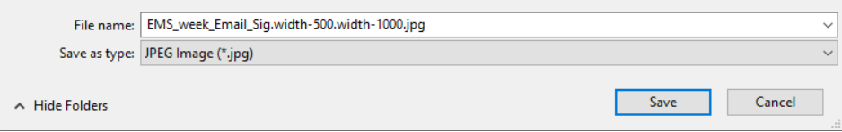
EMS week 2020 email signature image.jpg

- Open Outlook and click on File Options
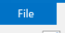

- Click on Mail

- Click on the Signatures button next to Create or modify signatures for messages

- Click on Default signature in the Select signature to edit box
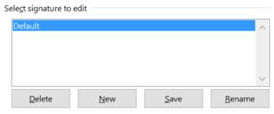
- In the Edit signature window, use the scroll bar on the right to scroll down to the bottom of the signature. Click to place your cursor under the U Health logo and press your enter key once.
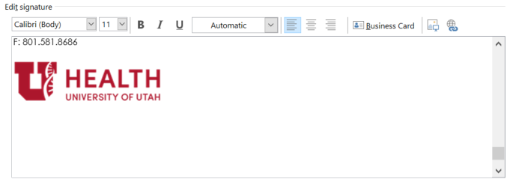
- Click on the Insert image button on the Edit signature toolbar

- Navigate to and select the image you saved in step 2. Then click the Inset button
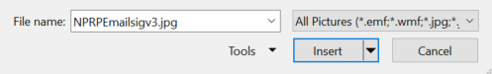
EMS week 2020 email signature image.jpg

- Click on the OK button and you’re finished
