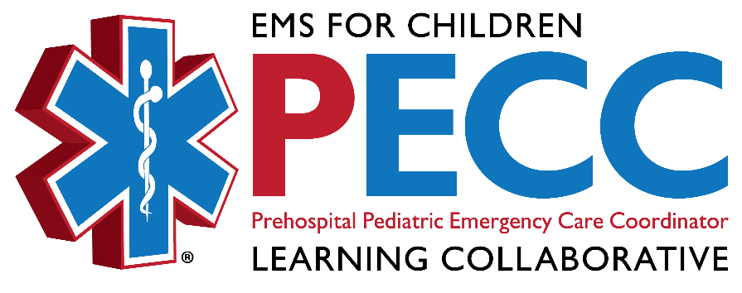
Pediatric Emergency Care Coordinator (PECC)
Equipment Grant Application Form

Wisconsin EMSC and Children’s Health Alliance of Wisconsin are offering a mini-grant to provide assistance in the establishment of Pediatric Emergency Care Coordinators in EMS services throughout Wisconsin. Mini-grants not exceeding $500 may be used to purchase equipment or provide training to benefit pediatric services.

Name of Service:

Contact Person:

Mailing Address:

Phone:

Email:

Equipment Requested:

Equipment Cost:

Equipment Purpose:

Please explain how this equipment will benefit the pediatric care that your service provides:

Service Director Signature Date

PECC Signature Date

