**Caring For Kids: A Region 7, Rural Pediatric Surge Tabletop Exercise**

Exercise Plan

25 April 2024

The Exercise Plan (ExPlan) gives state officials, healthcare providers, emergency managers and personnel from participating organizations information needed to participate in the exercise. Some exercise material is primarily intended for exercise planners, controllers, and evaluators, but participants may view other materials necessary to their participation. All exercise participants may view the ExPlan.

This publication was made possible by Award Number (U3REP190615-10-10) from the Administration for Strategic Preparedness and Response (ASPR). Its contents are solely the responsibility of the authors and do not necessarily represent the official views of ASPR or the Department of Health and Human Services.

# Exercise Overview

| **Exercise Name** | Caring for Kids: A Region 7 Pediatric Surge Tabletop Exercise |
| --- | --- |
| **Exercise Dates** | 25 April 2024 from 10:00am to 4:00pm EST |
| **Scope** | A Tabletop Exercise (TTX) and education presentations planned for 6 hours, conducted at BJ's Catering and Event Center, Gaylord, Michigan. Exercise play is limited to participating hospitals, clinics, and EMS agencies as needed to respond to three pediatric mass casualty incidents that exceeds local and regional resources. |
| **Mission Area(s)** | Readiness and Response |
| **ASPR Core Preparedness Capabilities** | Foundation for Health Care and Medical Readiness  Health Care and Medical Response Coordination  Continuity of Health Care Service Delivery  Medical Surge |
| **Objectives** | 1. **Conduct** a two-hour Pediatric Surge TTX featuring 3 iterations and scenarios of increasing complexity to stress pediatric disaster plans of 15 participating organizations.  2. Participating organizations **Evaluate** current pediatric response plans against the exercise scenarios to identify areas for improvement and report at least three proposed changes to their plans.  3. Consider public health/behavioral health response actions against exercise scenarios to **Identify** in total two interventions for incident recovery phase.  4. **Convene** pediatric experts and Region 7 Healthcare Coalition members for 35 minutes to present five briefings on regional pediatric capabilities, limitations, and practices.  5. **Determine** current pediatric transfer practices of Region 7 organizations internal and external to Region 7 during 25 minutes of briefings and discussions.  6. **Introduce** organizational techniques to respond and manage a pediatric surge during a 30-minute presentation. |
| **Threat or Hazard** | Pediatric Mass Casualty Incident |
| **Scenario** | Three scenarios: 1) Active Shooter, 2) School Bus Accident, and 3) Roof Collapse. See Exercise Injects in Participant guide for detailed scenario descriptions. |
| **Sponsor** | Region 7 Health Care Coalition and Region V for Kids Pediatric Disaster Center of Excellence |
| **Participating Organizations** | Functional participants are the Region 7 hospitals, clinics, trauma, and EMS agencies. All other participants in the exercise will participate in an observer/evaluator role. |
| **Point of Contact** | Kal Attie, MD  Medical Director  Region 7 Healthcare Coalition  CaringforKids@umich.edu |

# General Information

## Exercise Objectives and Core Capabilities

The following exercise objectives in Table 1 describe the expected outcomes for the exercise. The objectives are linked to ASPR Preparedness and Response capabilities (appendix C), which are distinct critical elements necessary to achieve the specific mission area(s). The objectives and aligned core capabilities are guided by Region 7 leadership and selected by the Exercise Planning Team.

| **Tabletop and Conference Objective** | **Preparedness and Response Capability** |
| --- | --- |
| **Conduct** a two-hour Pediatric Surge tabletop exercise featuring 3 iterations and scenarios of increasing complexity to stress pediatric disaster plans of 15 participating organizations. | Foundation for Health Care and Medical Readiness  Health Care and Medical Response Coordination  Medical Surge |
| Participating organizations **Evaluate** current pediatric response plans against the exercise scenarios to identify areas for improvement and report at least three proposed changes to their plans. | Foundation for Health Care and Medical Readiness  Medical Surge |
| Considerpublic health/behavioral health response actions against exercise scenarios to **Identify** in total two interventions for incident recovery phase. | Health Care and Medical Response Coordination Continuity of Health Care Service Delivery |
| **Convene** pediatric experts and Region 7 Healthcare Coalition members for 35 minutes to present five briefings on regional pediatric capabilities, limitations, and practices. | Foundation for Health Care and Medical Readiness |
| **Determine** current pediatric transfer practices of Region 7 organizations internal and external to Region 7 during 25 minutes of briefings and discussions. | Foundation for Health Care and Medical Readiness  Health Care and Medical Response Coordination |
| **Introduce** organizational techniques to respond and manage a pediatric surge during a 30-minute presentation. | Foundation for Health Care and Medical Readiness  Continuity of Health Care Service Delivery  Medical Surge |

Table 1. Exercise Objectives and Associated Core Capabilities

## Exercise Purpose

During a disaster or emergency, an organization’s ability to surge treatment and patient transportation is critical for a successful response. Multi-agency coordination is critical to an integrated response. The purpose of the *Caring for Kids: A Region 7 Pediatric Surge Tabletop Exercise* is two-fold: 1) test Region 7 Mass Casualty Incident (MCI) plans and 2) develop a keen understanding of pediatric resources available within the region.

## Exercise Timeline

The *Caring for Kids: A Region 7 Pediatric Surge Tabletop Exercise* is a 6 hour exercise and education session scheduled on Thursday, April 25th, from 10:00 am to 4:00 pm EST. Refer to Appendix A for the timeline.

## Supporting and Planning Materials

As tools and information for dissemination, exercise management and coordination, the following documents will be published to further describe and refine the exercise:

* Situation Manual 4 April 2024
* Participant Handbook 11 April 2024
* After Action Review (AAR) 30 June 2024

## Participant Roles and Responsibilities

The term *participant* encompasses many groups of people, not just those playing in the exercise. Groups of participants involved in the exercise, and their respective roles and responsibilities, are as follows:

* **Players.** Players are personnel who have an active, functional role in performing their regular roles and responsibilities during the exercise in accordance with organizational plans. Players discuss or initiate actions in response to the simulated emergency.
* **Facilitators.** Facilitators provide situation updates and control the exercise. They provide additional information or resolve questions as required.
* **Evaluators.** Evaluators evaluate and provide feedback on a designated functional area of the exercise.
* **Observers.** Observers view the exercise but do not play or control the exercise. Observers are invited to evaluate and comment on performance during the Table Top discussion.

## Exercise Assumptions and Artificialities

In any exercise, assumptions and artificialities may be necessary to complete play in the time allotted and/or account for logistical limitations. Exercise participants should accept that assumptions and artificialities are inherent in any exercise and should not allow these considerations to negatively impact their participation.

### Assumptions

Assumptions constitute the implied factual foundation for the exercise and, as such, are assumed to be present before the exercise starts. The following assumptions apply to the exercise:

* The exercise is conducted in a no-fault learning environment wherein capabilities, plans, systems, and processes will be evaluated.
* The exercise scenarios are plausible and occur as presented.
* During the exercise, participating agencies operate in accordance with their own policies and procedures.
* Exercise injects contain sufficient detail to allow players to react to information and situations as they are presented as if the simulated incident were real.
* Participating agencies may need to balance exercise play with real-world emergencies. Real-world emergencies take priority.

### Artificialities

During this exercise, the following artificialities apply:

* All exercise participants are staged and ready at 10:00am on 25 April 2024.
* Time periods for tasks have been significantly limited to facilitate a concise, effective exercise.
* The exercise is solely focused on Pediatric Mass Casualty Incident operations.
* Exercise participants are expected to fulfill Evaluator duties throughout: identifying, recording, and reporting exercise performance against established objectives.

# Exercise Logistics

## Safety

Exercise participant and observer safety takes priority over exercise events. The following general requirements apply to the exercise:

* Exercise Planners are responsible for providing a safe and secure environment for exercise participants. Any safety concerns must be immediately reported to the exercise host and facilitators.
* Exercise participants will follow venue safety rules and regulations for the duration of the day.
* For an emergency that requires assistance, use the phrase “**real-world emergency**.” The following procedures should be used in case of a real emergency during the exercise:
* Standard fire and safety regulations relevant to the at BJ's Catering and Event Center will be followed during the exercise: including alarm activation, use of fire suppression equipment, evacuation routes, and muster locations. Upon evacuation, report to exercise planners for personnel accountability.
* Emergency Medical Services: The staff at BJ's Catering and Event Center will coordinate with local emergency medical services in the event of a real-world emergency.

# Post-Exercise and Evaluation Activities

## Debriefings

Post-Exercise debriefings aim to collect sufficient relevant data to support effective evaluation and improvement planning.

### Report Outs

At the conclusion of exercise play, controllers facilitate a Report Out to allow players to discuss strengths and areas for improvement. Evaluators seek clarification regarding player actions and decision-making processes. All participants and observers may attend. The Repot Out will not exceed 30 minutes.

## Evaluation

### After-Action Report

The AAR summarizes key information related to evaluation. The AAR primarily focuses on the analysis of core capabilities, including capability performance, strengths, and areas for improvement. AARs also include basic exercise information, including the exercise name, type of exercise, dates, location, participating organizations, mission area(s), specific threat or hazard, a brief scenario description, and the name of the exercise sponsor and POC.

## Improvement Planning

Improvement planning is the process by which the observations recorded in the AAR are resolved through development of concrete corrective actions, which are prioritized and tracked as a part of a continuous corrective action program. Improvement Planning will occur at two level. First, individual organizations will develop and implement corrective measures in their plans to address gaps identified during the table top exercise. Second, exercise and education planners will evaluate the conduct of the event, identify areas for improvement, and implement corrective measures during follow on exercises.

# Participant Information and Guidance

## Exercise Rules

The following general rules govern exercise play:

* Real-world emergency actions take priority over exercise actions.
* Exercise players will comply with real-world emergency procedures, unless otherwise directed by the control staff.

## Players Instructions

Players should follow certain guidelines before, during, and after the exercise to ensure a safe and effective exercise.

### Before the Exercise

* Review appropriate organizational plans, procedures, and exercise support documents.
* Be situated and seated in the exercise and conference site at least 10 minutes before the exercise starts.

### During the Exercise

* Respond to exercise events and information as if the emergency were real.
* Do not engage in personal conversations with controllers, evaluators, observers, or media personnel.
* If you do not understand the scope of the exercise, or if you are uncertain about an organization’s participation in a exercise, ask an exercise planner.
* Parts of the scenario may seem implausible. Recognize that the exercise has objectives to satisfy and may require incorporation of unrealistic aspects.
* Speak when you take an action. This procedure will ensure that evaluators are aware of critical actions as they occur.
* Maintain a log of activities. Many times, this log may include documentation of activities that were missed by a controller or evaluator.

### After the Exercise

* Participate in the Debrief conducted at the end of the day.
* Provide any notes or materials generated from the exercise to the Exercise Planners for review and inclusion in the AAR. Submit materials, notes and comments via [CaringforKids@umich.edu](mailto:CaringforKids@umich.edu).
* When published, an AAR will be sent to all collected email addresses of exercise participants for their organization’s record and use.

Exercise Schedule



**The exercise agenda is subject to change.**

Exercise Functional Participants

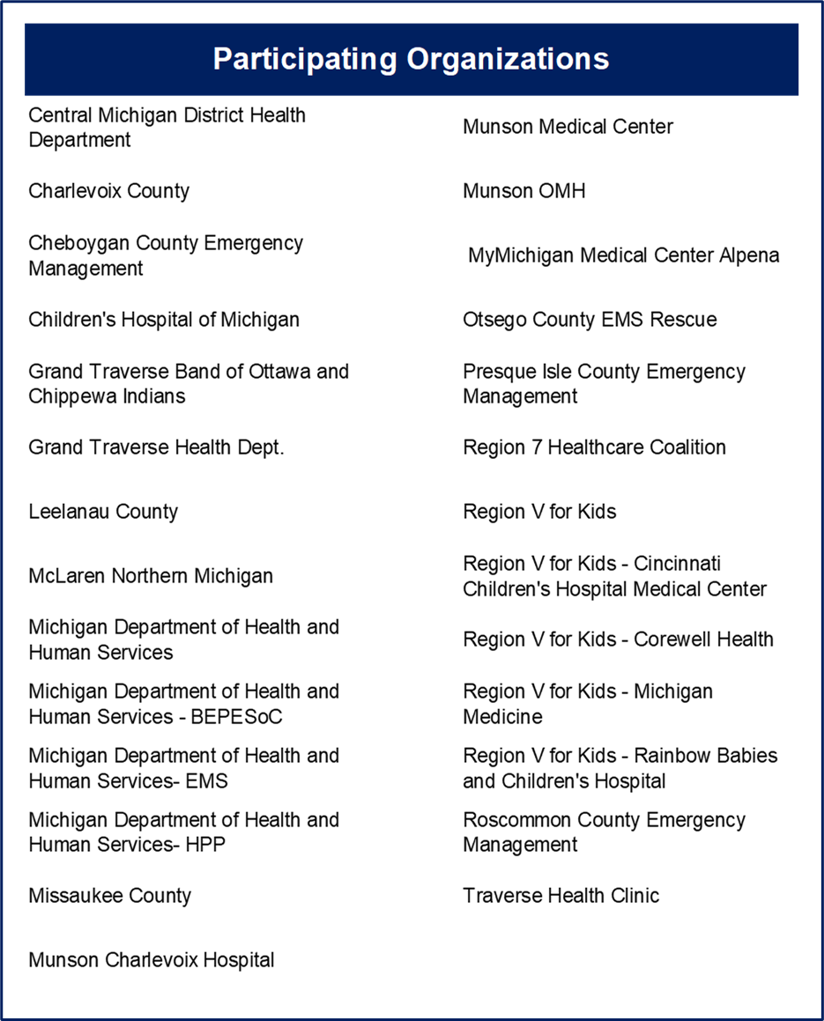

**Participating Organizations are subject to change.**

ASPR Preparedness and

Response Capabilities



Acronyms

