Advanced Understanding of Children’s Hospitals’ Disaster Telehealth Capability

Region V for Kids Pediatric Center of Excellence

June 27, 2023

This publication was made possible by Award Number (U3REP190615-10-10) from the Office of the Assistant Secretary for Preparedness and Response (ASPR). Its contents are solely the responsibility of the authors and do not necessarily represent the official views of ASPR or the Department of Health and Human Services.



**Table of Contents**

Executive Summary Page 3

Background Page 4

Methodology Page 5

Results Page 6

Conclusions Page 14

Appendix A: Region V Telehealth Survey Page 15

Appendix B: Survey Announcement Page 24

Appendix C: Solicitation Message Page 25

**Executive Summary**

In March and April 2023, the Telehealth Workgroup of the Region V for Kids Pediatric Center of Excellence conducted a seventeen-question survey of children’s hospitals to examine regional telehealth capabilities. The survey built upon previous research by gathering more focused, additional information on current programs, practices, and capacities. This survey exposed one key lesson: *telehealth is principally organized and used as an instrument of routine clinical operations: telehealth for disaster operations is an accessory function*. As a tool of general healthcare, hospitals have embraced telehealth and expanded its use into multiple pediatric specialties. To fully respond to a pediatric surge, planners must leverage and attach disaster preparedness to the current expansion of telehealth operations.

**Background**

In support of an overarching grant objective to *develop coordinated pediatric disaster care capability*, the Region V for Kids Telehealth workgroup previously conducted surveys of ten partner hospitals on their telehealth hardware, software, and platform (See reports of prior surveys [here](https://emscimprovement.center/domains/preparedness/asprcoe/eglpcdr/telehealth/)). The 2021 and 2022 surveys accomplished the first step to understanding the current pediatric telehealth landscape of partner hospitals.

To advance the understanding and collect granular data about telehealth capabilities for pediatric disaster response, a new survey was developed to identify current practices, programs, and surge capacity. Developing a regional telehealth network requires coordination of diverse types of surge capacity. The 2023 survey was designed to gather refined information about current capabilities, programs, and community impact at each children’s hospital.

**Methodology**

The survey population consisted of ten children’s hospitals in Region V for Kids’ six state footprint. Each facility submitted one response. The survey was conducted as a web-based questionnaire using the Qualitrics platform. Questions were a mix of multiple choice, yes/no, matrix table, and limited character, free-text queries. A typical question was: Please identify the number one, most common obstacle preventing the use of telehealth to provide pediatric care during routine (non-disaster) operations.

The survey design was crafted to place minimal burden upon the respondent. In theory, a hospital representative well versed in telehealth operations should be able to complete the survey in under 20 minutes. To facilitate that objective, the follow directions were provided to respondents:

* Please do not feel compelled to invest significant time tracking down specific data points.
* Survey responses reporting little to no telehealth capability are critical data points for identifying gaps in pediatric telehealth networks.
* Please complete the survey even if the majority of responses are blank.

Additionally, the survey was composed to:

* contain a narrow scope of topics to facilitate completion by a single hospital representative.
* allow almost all questions to be optional, thereby supporting a representative’s quick submission.

**Results**

1. Telemedicine Pediatric Environmental Scan

The telehealth survey was organized around four topics: administrative, outreach and impact, capacities, and barriers. Six administrative questions gathered point of contact, hospital name and type of hospital information. Administrative data is omitted from this report to de-identify survey responses. Outreach included five questions to identify current consultation practices, alternate care site telehealth, and community engagement. Routine and surge telehealth capacities were addressed in four questions. The final three questions addressed barriers to successful patient engagement using telehealth.

1. 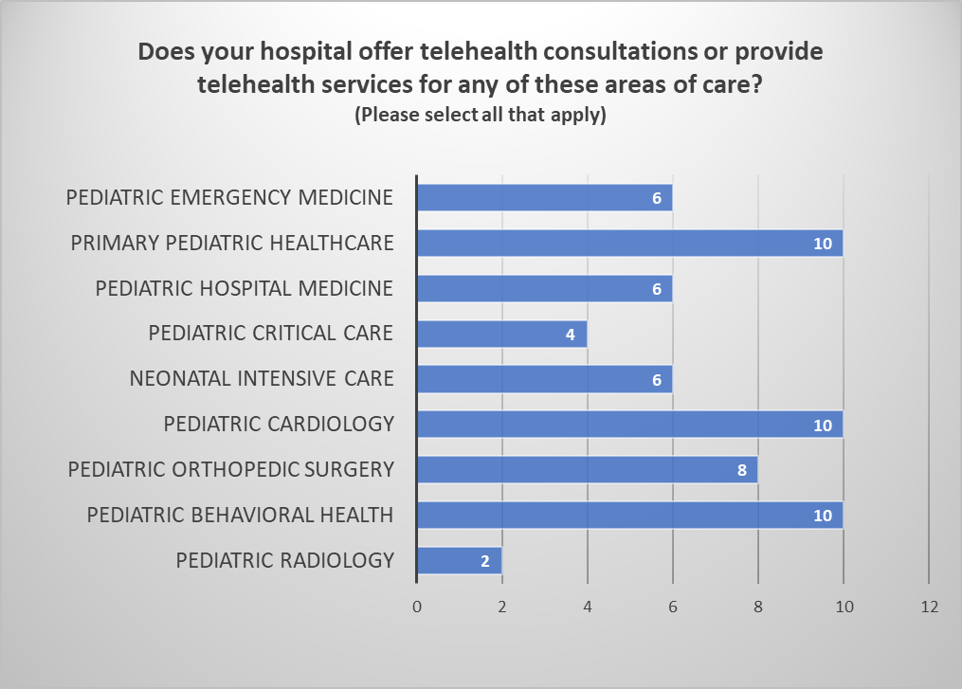

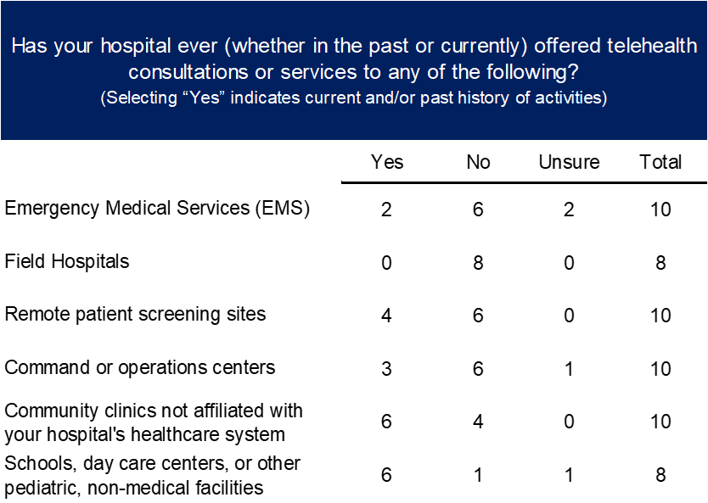

















**Conclusions**

Taken as a whole, analysis of survey results provides one key takeaway: telehealth is primarily conceived and used as a tool for routine clinical operations, with disaster operations as an accessory function. Investments in pediatric telehealth for preparedness and response have not kept pace with the general telehealth expansion. All metrics related to disaster preparedness and response acutely lag indicators of clinical usage. Currently, telehealth is solely a tool of clinical operations, not disaster response.

Additional observations include:

* Children’s hospitals have a strong foundation and wide scope of pediatric telehealth capability and capacity.
* As a tool of disaster response, telehealth is not sufficiently incorporated into children’s hospital plans and response systems.
* As a mitigation factor for pediatric disaster management, robust, clinical telehealth programs elevate the threshold of patient volumes and insulate against surge incidents.
* Medical professionals are generally more adept and open than their patients to using telehealth as a form of primary physician engagement.
* Addressing patient barriers to telehealth is the effort most likely to improve the overall impact of telehealth programs.
* Children’s hospitals have greatly expanded the reach of telehealth into the various pediatric specialties.















