ED Staff Resources Guide
Audience: ED administrators who have funds to purchase items for the pediatric patients in the ED and want more guidance as to what to buy and how to use items with pediatric patients.
Objective: This guide contains a variety of suggested materials for different age groups as well as what materials are considered safe and not safe for pediatric patients presenting with a behavioral health condition. The purpose of this guide is to provide a list of materials you can consider purchasing for your ED. These items should still be used under the supervision of a sitter/observer or parent.
Index Page
Safety Zone Materials 2
Description: This grid applies to all ages and provides a variety of materials that are divided into three categories of safety for pediatric patients with a behavioral health condition. Green equals safe for all. Yellow should be tailored to individual safety needs of the patient and discussed with your behavioral health team. Red are typically never safe.

Distraction Activities By Age/Development 3
Description: This guide contains a list of distraction activities by age, including many of the items from the safety zone materials grid. This guide is provided in word format so that you can tailor this page to existing resources within your ED. Print copies of page 3 to place in your ED with the self-care guide as a page for caregivers and patients to use as a checklist of what items they would like to use while in the ED.

Individual Bags for Behavioral Health Patients Example 4
Description: If your ED decides to purchase items for pediatric patients, you can consider making individual bags for these patients prior to arrival. This is an example of behavioral health activities bag that you can make ahead of time for any pediatric patient with a behavioral health condition. This list can be tailored based on what you decide to purchase for your ED.

Example Purchasing Guide 5
Description: This page lists several of the example items above, and links on various websites where you can purchase these items (price included). We do not endorse any of these products as being superior to any other product, and we are receiving no financial endorsement from these items. This list is meant to give you examples of items you can purchase. You can also search for many of these items via google shopping and amazon.

Content Adapted from:

Distraction Activities By Age/Development
Before giving any items to behavioral health patients it is important to discuss limitations and restrictions with care team.
Preschool (3-5yrs)
- Coloring Pages/Large sized Crayons
- Stickers
- Simple iSpy Books
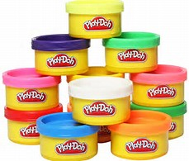
- Playdoh (does contain wheat/gluten)
- Memory Games, Candyland
- Puzzles
- Imaginary Play Items
- Movies/Shows
- Velvet art
Only for select pts deemed safe to participate
- Water Coloring Painting, Block Legos
School Age (6-12yrs) *also applicable for adolescent patients
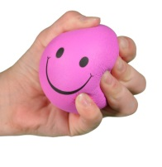
- Detailed Coloring Pages/Large sized Crayons
- Sudoku*
- Word Searches*
- Deck of Cards*
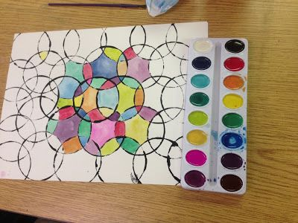
- Board Games*
- Mad Libs
- Origami*
- Sticker by Numbers
- Stress Balls, Playdoh (contains wheat/gluten)
- Movies/Exercise for kids DVDs
- Painting Projects
Only for select pts deemed safe to participate
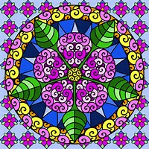
- Video Games, Markers, Legos
Adolescent (13-18yrs)
- Movies/Yoga DVDs
- Journals
- Music
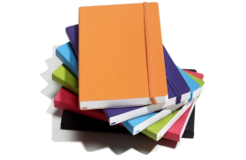
- Stress Balls
- Adult Coloring Books/Mandalas
- Magazines/Books
Only for select pts deemed safe to participate
- Video Games

Individual Bags for Behavioral Health Conditions
Slime kit – to make: 6oz of glue + ¼ cup of Elmer’s magical liquid + food coloring or water color (use urine cups for storage)
(2) Sticker by number pages
(2) Velvet art pages
(5) Colored sheets of origami paper + instructions for 2 folding projects
(2) Learn to draw animal instructions + crayons + 4 sketch paper pages
Foam stress ball
Puzzle packets for older children – (2) crosswords, (2) word searches, (2) MadLibs, & (2) Sudokus

Example purchasing guide: We do not endorse any of these products as being superior to any other product and we are receiving no financial endorsement from these items. This list is meant to give you examples of items you can purchase. Click on hyperlink to see examples of items you can consider purchasing for your pediatric patients. Items highlighted in green are green zone items and in yellow are yellow zone items (see page 2 for further details about green zone and yellow zone).
Purpose | Vendor | Item Description | Price | Link
Active | Amazon | Elmers Magical Liquid (for homemade slime) | $9.39/qt | Elmers Magical Liquid
Active | Amazon | Over the Door Basketball Hoop | $14.99 | Nerf Sports Dude Perfect Mini Perfectshot Hoop
Active | Amazon | Soccer (purchase ball set, use tape to make goal) | $9.99 | Mini Ball Assortment
Active | Amazon | Playing Cards | $12.99 | Cards
Active | Amazon | Space Hopper Ball w/ pump | $16.90 | Space Hopper
Active | Amazon | True Balance Coordination Game | $24.99 | True Balance Coordination
Active | Amazon | Fabric Dartboard with 20balls | $24.90 | Dartboard
Active | Amazon | Hula Hoop | $22.99 | Hula Hoop
Active | Amazon | Yoga Spinner Game | $14.86 | Yoga Spinner
Active | Amazon | Yoga Cards for Kids | $13.99 | Yoga Cards
Active | Amazon | Denise Austin's Fit Kids Workout DVD | $9.99 | Kids Workout DVD
Active | Amazon | 6 Fit Kids' Workouts DVD | $15.69 | Kid Workout DVD
Active | Amazon | Tae Bo with Billy Blanks DVD | $18.98 | Tae Bo DVD
Active | Amazon | Yoga for Families DVD | $13.49 | Yoga Family DVD
Active | Amazon | Yoga for Kids Outerspace DVD | $7.57 | Yoga Outerspace
Active | Amazon | Yoga for Beginners DVD Set | $23.99 | Yoga for Beginners
Active | Amazon | Yoga Mats (10 pack) | $74.99 | Yoga Mats
Creative | Amazon | Model Magic Clay | $40.17 | 75 Assortment Pack
Creative | Amazon | Window Art Markers (pack of 8) | $8.99 | Window Marker Pack
Creative | Amazon | Crayola Classpack Thin Markers (QTY 200) | $40.93 | Thin Markers
Creative | S&S | Velvet Art Detailed Posters (pack of 30) | $28.79 | Detailed Posters
Creative | S&S | Velvet Art Mandalas (pack of 40) | $25.79 | Mandalas
Creative | S&S | Velvet Art Landscapes (pack of 50) | $81.99 | Landscapes
Creative | S&S | Fabric Markers Classpack (set of 80) | $71.79 | Fabric Markers
Creative | S&S | Fabric case- no strings (pack of 12) | $18.99 | Fabric Case
Creative | Amazon | Model Magic Clay Classpack white (QTY 75) | $31.59 | White Model Magic
Creative | Amazon | Paint by Sticker (Kids) | $ 9.95 | Paint by Sticker (Kids)
Creative | Amazon | Paint by Sticker | $14.95 | Paint by Sticker
Creative | Amazon | Origami (300 sheets) | $13.95 | Origami
Creative | Amazon | Canvas panels 8x10 12 pack (no staples) | $15.99 | Canvas
Creative | Amazon | Journals to give-away(pack of 8) | $43.59 | Safe Journals
Creative | Amazon | Sketch pad perforated pages (pack of 3) | $35.27 | Sketch Pad
Creative | Amazon | Watercolors (24 pack) | $12.97 | Watercolors
Creative | Amazon | Watercolor Paper (pack of 2 - 60 sheets) | $21.99 | Watercolor Paper
Puzzle | Amazon | Rubix Cube (set of 5) | $19.99 | Rubix Cube
Puzzle | Amazon | 3D Puzzle color and put together (set of 10) | $16.99 | 3D Puzzle
Puzzle | Amazon | 3D Puzzle color and put together (set of 10) | $18.99 | 3D Puzzle
Puzzle | Amazon | Min individual Lego boxes cars (set of 12) | $27.95 | Mini Lego-Cars
Sensory | Amazon | Nee Doh Stress Balls (6 pack) | $19.89 | Stress Balls
Sensory | Amazon | Pop Tubes | $10.97 | Pop Tubes
Sensory | Amazon | Kinetic Sand (pack of 6) | $25.99 | Kinetic Sand
Sensory | Amazon | Snap and fit fidget toy (pack of 4) | $7.27 | Fidget Toy
Therapeutic | Amazon | 500 piece puzzle | varies | Search puzzle for variety
Therapeutic | Amazon | Kinetic Sand | varies | Search kinetic sand for variety
Therapeutic | Amazon | White Noise machine | $21.99 | white noise machine

Autism specific example items
Purpose | Vendor | Search Description | Price | Link
Active | Amazon | Sit and Spin | $34.25 | Sit and Spin
Active | Amazon | Youth Yoga ball with handle | $19.99 | Yoga Ball for Toddler/School Child
Active | Amazon | Large Soft Blocks | $24.99 | Soft Blocks

