Participant Checklist
Note: Detailed information for each checklist activity is available in the Handbook.

Register: Visit Securing Resources Registration to register for the exercise.

Preview Questions: Review demonstration poll questions on pages B-2 through B-5 of the Participant Handbook.

Review Best Practices: Review videoconferencing best practices at Best Practices.

Join Teams: The Teams link for joining the Securing Resources demonstration is:
https://teams.microsoft.com/l/meetup-join/
Meeting ID: 259 071 894 199 Passcode: L53Gx9
Or dial 616-552-9548, ID: 347 764 334# to join by phone.

Join Menti: Join the Mentimeter interactive polling presentation by opening www.menti.com and using code 2325 526 or use this QR Code:

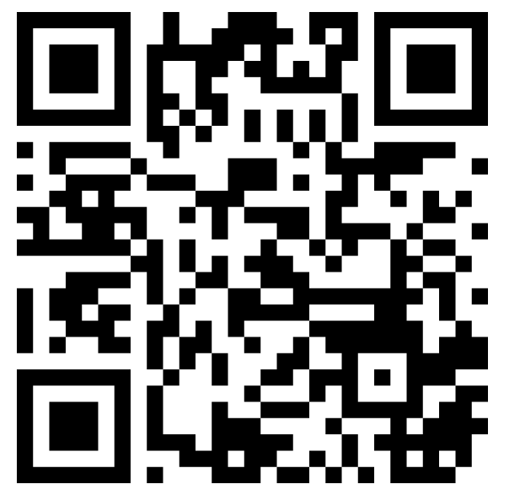

Exercise: Use the various techniques to participate in the exercise: polls, chat, discussion, and email.

Key Points of Information: The demonstration will include a 30-minute session of interactive review and data identification. At 11:20 am, each participant is requested to have the Mentimeter presentation open and to be prepared to answer a series of questions. Please select the correct response based upon the information displayed in the Pediatric Dashboard.

Points of Contact:
Exercise Website: Securing Resources webpage
Exercise Email: SecuringResources@umich.edu

