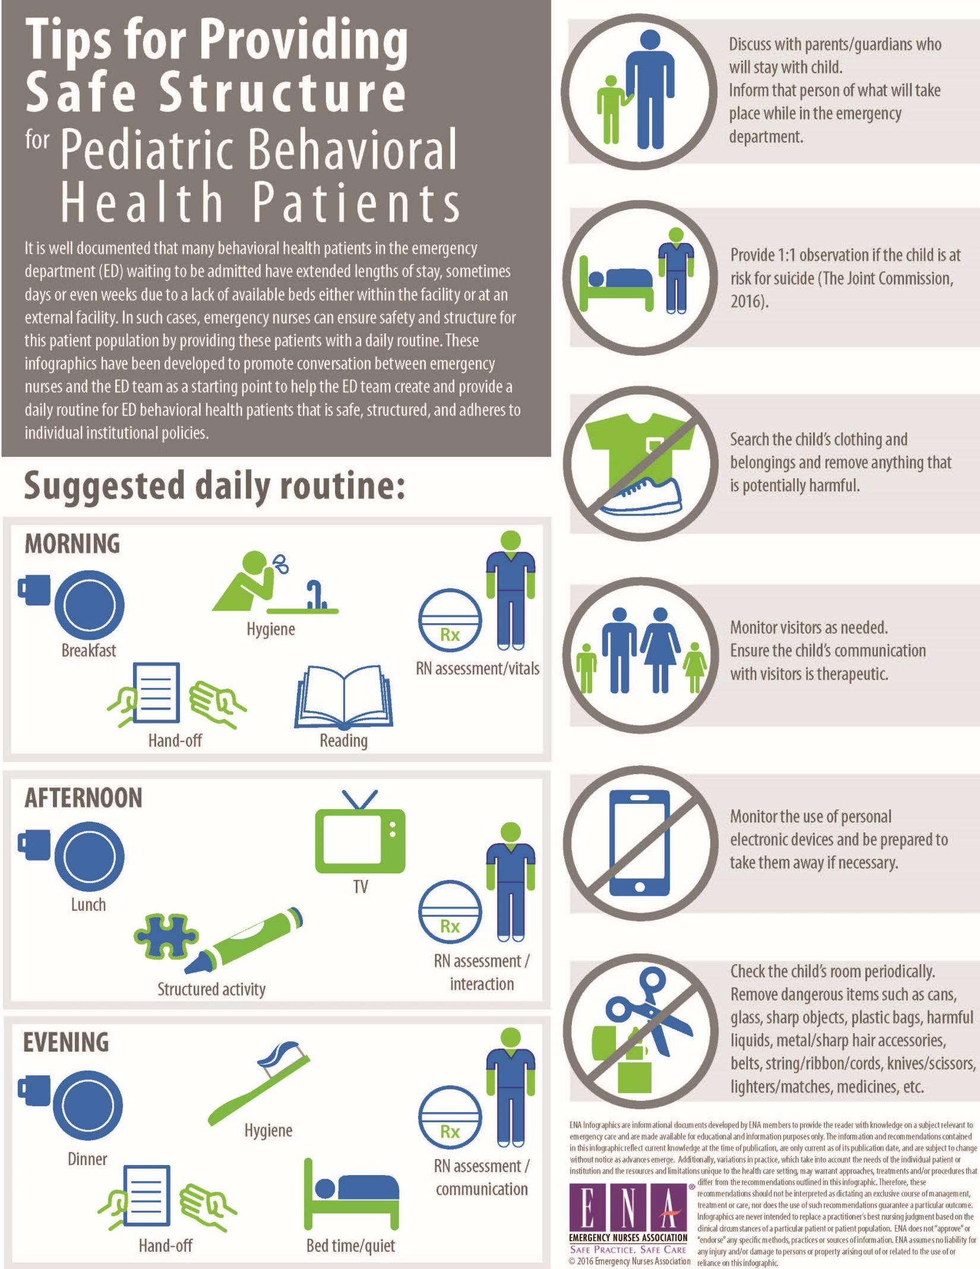
Your Daily Schedule Today’s date: ___________
Your nurse today is: _____________________________
Your medical provider today is:____________________
Time | Activities Scheduled | Activities Completed
7-9 am | Breakfast time  Morning self-care  Create goal for the day  Check-in with nurse (or mental health provider, if available) | - ______________________  - ______________________  - ______________________  - ______________________
9-11am | Team safety review  Movement/exercise activities*  Activities* | - ______________________  - ______________________  - ______________________
11am-1pm | Lunch time  Quiet/rest time | - ______________________  - ______________________
1-3pm | Movement/exercise activities*  Activities*  Snacks available | - ______________________  - ______________________  - ______________________
3-5pm | Review goal for the day  Check-in with nurse (or mental health provider, if available) | - ______________________  - ______________________  - ______________________
5-7pm | Dinner time  Activities* | - ______________________  - ______________________
7-9pm | Evening self-care  Sleep/relaxation activities*  Bedtime | - ______________________  - ______________________  - ______________________
Created by: Jessica Ranford and Madeleine Thoms

