Eastern Great Lakes Pediatric Consortium for Disaster Response

Advancing Pediatric Telehealth Capability: Use of Technology During Disaster Response



Data Collection Plan

20 May 2021

The Data Collection Plan gives primary investigators, state officials, healthcare providers, emergency managers and personnel from participating organizations information about collection of exercise related data. All exercise participants may view the Data Collection Plan.

This publication was made possible by Award Number (U3REP190615-10-10) from the Office of the Assistant Secretary for Preparedness and Response (ASPR). Its contents are solely the responsibility of the authors and do not necessarily represent the official views of ASPR or the Department of Health and Human Services.

# Data Security and Usage

## Identity Security and Privacy

In an attempt to identify one participant’s responses across all the collection tools, participants are asked to provide identifying information in the form of names and email addresses. Personal information is collected only for the purposes of linking a participant's response across several surveys used throughout the exercise.  All data will be de-identified early in the analysis process. Personal information will not be used to contact participants or included in any reports or publications.

## Recordings

As constructed, the Advancing Capabilities exercise will feature nine, pre-recorded videos demonstrating telehealth tasks for evaluation by exercise participants. Additionally, an overarching recording of the entirety of the exercise will be recorded on the Zoom platform. Video files provided to exercise planners will be publically presented only once during the exercise. The videos will not be shared outside of the core exercise planning team. **Video files and the Zoom recording will not be shared** with exercise participants

## Video Destruction

Given that each organization participating in video production has their own set of policies for photo and video production, publication and release, and in order to overcome the mine field of accommodating competing interests, exercise planners made a commitment that **all recording will be destroyed within 72 hours** of the exercise.  Destruction includes the video files and Zoom recording. The Zoom recording is retained for an initial 72-hour period for the sole purpose of collecting participant comments and converting them into useable data points. Confirmation of video file destruction will be provided to organizations that participated in video production.

## Data Sharing

Upon collection, data from the multiple collection tools will be consolidated and converted into a useable, common format. The consolidated data package will be available for analysis by any primary investigator that is a member of the Eastern Great Lakes Pediatric Consortium for Disaster Response (EGLPCDR). Submit requests for data from non-EGLPCDR members to the advancing Capabilities exercise contact email: [AdvancingCapability@umich.edu](mailto:AdvancingCapability@umich.edu) . Eternal requests will be evaluated on a case-by-case basis by the primary grant investigators.

## Data Destruction

In accordance with U.S. Department of Health & Human Services grant policy, all data collected as a result of the Advancing Capability exercise will be destroyed in May 2024.

## Publication

As currently planned, there will be two publications created from Advancing Capability exercise data: 1) an After Action Review of the exercise and 2) a Proof of Concept Report (White Paper).

Both of these documents will be added to the [Advancing Capability website](https://emscimprovement.center/domains/preparedness/asprcoe/eglpcdr/telehealth/#:~:text=Advancing%20Pediatric%20Telehealth%20Capability%3A%20Use%20of%20Technology%20During%20Disaster%20Response&text=The%20Eastern%20Great%20Lakes%20Pediatric,test%20pediatric%20disaster%20telehealth%20activities.) when published. If interested, any EGLPCDR primary investigator may analyze exercise data and publish articles or papers to professional journals. All publication resulting from the Advancing Capability exercise will include the following acknowledgement:

*This publication was made possible by Award Number (U3REP190615-01-01) from the Office of the Assistant Secretary for Preparedness and Response (ASPR). Its contents are solely the responsibility of the authors and do not necessarily represent the official views of ASPR or the Department of Health and Human Services.*

# Data Collection and Post-exercise Activities

## Surveys and Polls

Exercise surveys and live polling are detailed below in the order that they will occur prior, during and after the exercise.

## Pre-Exercise Survey

Participants are asked questions to assess professional qualifications, telehealth expertise and emergency management experience. The survey is available at [Pre-Exercise Survey](https://umich.qualtrics.com/jfe/form/SV_a95Z2rhIBIG6jLE) (link). See Appendix A for survey questions.

## Video Production Survey

Participants who took part in producing a pre-recorded video are asked to complete a Video-Production survey. This survey asks more detailed, telehealth related. The video production survey is available at [Video Production Survey](https://umich.qualtrics.com/jfe/form/SV_50b9VrhCjIgUPUG) (link). See Appendix B for survey questions.

## Word Cloud

As an ice breaker, a word cloud will display participant responses to interactive questions.

## Menti-Meter

Menti-meter is an interactive presentation platform that provides immediate aggregated responses. Menti-meter will be used during the exercise to gather participant responses. See Appendix C for survey questions.

## Zoom Chat

Participant questions can be submitted throughout the exercise via Zoom chat. An exercise controller will monitor the chat, address individual questions where possible and notify the exercise facilitator of questions for group discussion. A transcript of the Zoom chat will be downloaded and added to the exercise record.

## Post-Exercise Survey

Building upon the pre-exercise survey, all participants are asked to complete a short survey to assess changes in opinion of telehealth as a result of the exercise. The post exercise survey is available at [Post-Exercise Survey](https://umich.qualtrics.com/jfe/form/SV_aVGYtvgpZqhHcLY) (link). See Appendix D for survey questions.

## Debriefings

Post-exercise debriefings aim to collect relevant data to support effective evaluation and improvement planning.

### Hot Wash

At the conclusion of exercise play, the exercise facilitator will conduct a short Hot Wash to allow participants to discuss strengths and areas for improvement for the exercise. The facilitator will also solicit final feedback on the utility of telehealth as a tool for pediatric disaster and surge response. The Hot Wash should not exceed 30 minutes.

**Leadership Debriefing**

EGLPCDR senior leadership participate in a facilitated debriefing during the next consortium meeting immediately following the exercise. During this debriefing, leadership provide an overview of their observations and discuss exercise strengths and areas for improvement.

## Evaluation

### Exercise Evaluation Guides

EEGs assist evaluators in collecting relevant exercise observations. EEGs document exercise objectives and aligned core capabilities, capability targets, and critical tasks. Each EEG provides evaluators with information on what they should expect to see demonstrated in their functional area. The EEGs, coupled with Hot Wash and Leadership Debriefing notes, are used to evaluate the exercise and compile the After-Action Report (AAR).

### After-Action Report

The AAR summarizes key information related to evaluation. The AAR primarily focuses on the analysis of core capabilities, including capability performance, strengths, and areas for improvement. AARs also include basic exercise information, including the exercise name, type of exercise, dates, location, participating organizations, mission area(s), specific threat or hazard, a brief scenario description, and the name of the exercise sponsor and POC.

## Proof of Concept Reporting (White Papers)

In support of ASPR grant objectives and end of grant reporting, Proof of Concept Reporting is a process by which the observations recorded in the AAR are resolved through development of policy proposals, which are tracked and collated as a part of end of grant report development.

### Primary Investigators Meeting

Taking advantage of an existing schedule of bi-monthly, Primary Investigators meetings, an exercise evaluation session is conducted with leaders within the grant consortium to debrief the exercise and to review and refine a draft AAR and end of grant report.

### End of Grant Report

The End of Grant Report identifies specific policies, models, obstacles, and recommendations for development of regional pediatric disaster and surge response. The End of Grant Report is a consolidated collection of White Papers from all grant work groups. The Proof of Concept paper that results from this exercise will be one section of a much larger, End of Grant Report.

# IT, Virtual Platform, and Applications Integration Plan

## Video Conferencing Platform

The Advancing Capability exercise will be hosted on the Zoom videoconferencing platform. To overcome potential technical issues, multiple meeting hosts have been identified as “Plan B” be creating host redundancy. The meeting will be recorded and saved for a period of 72 hours. The meeting room is configured so that all exercise participants can do the following:

Open and control their video feed

Open and control their audio feed

Select a computer or phone audio feed

Mute and Unmute their audio feed

Join the meeting anytime during the exercise

Submit question and comments via Chat

Meeting host will have additional privileges to:

Mute participants

Remove participants

Screen share

Record the meeting

## Video Conference Security Measures

To facilitate a secure, professional video conference, the follow measures will be used to manage the meeting:

Meeting Passcode to limit access to registered exercise participants

Meeting Waiting Room to screen participants prior to approving access to the meeting

Onsite AV/IT support to address disruptions occurring on the platform

Moderated discussions

Dedicated monitoring of conversation to identify disruptive participants

Moderator muting of disruptive participants

Moderator removal from the meeting of disruptive participants

Recording of virtual discussions

Collection of participant commentary and feedback in accessory platforms not critical to exercise management

## Mentimeter

Mentimeter is an interactive presentation platform capable of collecting and displaying real-time polling answers from the audience. Mentimeter also collects and saves polling data for post-exercise analysis. Mentimeter supports participants joining the polling at any time during the exercise. An Advancing Capability Mentimeter presentation will be live for the duration of the exercise and synchronized with video presentation. However, as an auxiliary application, Mentimeter does not provide the participant experience occurring in the Zoom video conference. **It is highly recommended** that participants establish and maintain two internet streams of connectivity: one for the Zoom video conference and a second one for Mentimeter polling.

## Qualtrics

Qualtrics is a powerful online survey tool that allows researchers to build surveys, distribute surveys and analyze responses from one convenient platform. Qualtrics is the platform used to conduct three Advancing Capability surveys:

[Pre-Exercise Survey](https://umich.qualtrics.com/jfe/form/SV_a95Z2rhIBIG6jLE)

[Video Production Survey](https://umich.qualtrics.com/jfe/form/SV_50b9VrhCjIgUPUG)

[Post-Exercise Survey](https://umich.qualtrics.com/jfe/form/SV_aVGYtvgpZqhHcLY)

## Facilities

The Advancing Capabilities will be hosted from a conference room at an EGLPCDR member location. The room has the following features:

Video Conferencing interface

Polycom Conferencing Phone

LCD Monitor with VGA and HDMI ports

Podium

Whiteboard and/or Chalkboard

## Support Services

Multiple Audio Visual and Information Technology (AV/IT) personnel from an EGLPCDR member organization will be on site throughout the exercise. The AT/IT experts will be available to address any equipment, connectivity and technical issues. AT/IT experts will also closely monitor the video conference and intercede to mute and/or remove disruptive participants as necessary. AT/IT experts will conduct pre-exercise testing to validate equipment, systems and connectivity needed to support the Advancing Capability exercise.

## Platform Integration

Of the multiple platforms and applications used to support the Advancing Capability exercise, only two will operate simultaneously. While the exercise occurs on a video conferencing platform, a Mentimeter interactive presentation will actively poll exercise participants. Synchronization of the two systems will occur by active human intervention during the exercise. Synchronization is a simple of task of advancing Mentimeter slides to match the pace of the exercise.

# General Information

## Exercise Goals, Objectives and Core Capabilities

The following exercise goals in Table 1 describe the expected outcomes for the exercise. The goals are linked to core capabilities, which are distinct critical elements necessary to achieve the specific mission areas. Table 2 refines exercise goals to exercise objectives, with objectives representing the tasks necessary to achieve each goal. The goals, objectives and aligned core capabilities are guided by ASPR grant guidelines and EGLPCDR senior leadership and selected by the Exercise Planning Team.

| Exercise Goal | Core Capability |
| --- | --- |
| Strengthen Pediatric Disaster Care Preparedness and Healthcare System Coordination | Coordinated regional pediatric response |
| Develop Coordinated Pediatric Disaster Care Capacity | Coordinated regional pediatric response |
| Enhance Statewide and Regional Medical Surge | Coordinated regional pediatric surge |
| Assess the value of telehealth and video conferencing capability as a tool for pediatric disaster and surge response. | Coordinated regional pediatric response |

Table 1. Exercise Goals and Associated Core Capabilities

| Exercise Goal | Objectives |
| --- | --- |
| Strengthen Pediatric Disaster Care Preparedness and Healthcare System Coordination | * Exercise planners bring together six children’s hospitals, six partner hospitals and two state departments of health from Michigan and Ohio in a virtual Demonstration Exercise to collectively assess telehealth no later than 20 May 2021 * Exercise planners host health care coalitions and health departments for a 4-hour virtual Demonstration Exercise to discuss and develop telehealth policies and practices * Participating children’s hospitals, partner hospitals and state departments of health each partner to develop and present one, 20-minute telehealth task that is useful during pediatric disaster and surge response. |
| Develop Coordinated Pediatric Disaster Care  Capacity | * Over the course of two, 15-minute engagements, Ohio Department of Health and Michigan Department of Health and Human Services cooperatively work to identify critical pediatric supply stocks and formulate plans for emergency re-supply. * Ohio based pediatric Behavioral Health experts provide 1 hour of Just-in-Time training to Michigan peers on pediatric related mental health issues and treatments in an effort to develop cross-border cooperation * Two Children’s hospitals will attempt en route telehealth consultation with critical transport, ground and air ambulances |
| Enhance Statewide and Regional Medical Surge | * During opening remarks, the exercise facilitator will highlight the potential of using telehealth and video conferencing as tools for pediatric disaster response to prompt and motivate exercise participants to test, review and modify telehealth practices within their organizations * For 45-minutes, exercise participants will examine and discuss both positive and negative lessons learned during the telehealth demonstrations to identify best practices and how the practices apply during pediatric disaster and surge * Grant investigators will synthesize, analyze and report exercise generated data on the utility of telehealth as a tool for pediatric disaster and surge response as identified by exercise participants no later than 31 July 2021 |
| Assess the value of telehealth and video conferencing capability as a tool for pediatric disaster and surge response. | * Children’s hospitals will present nine, 20-minute pre-recorded videos to exercise participants in order to evaluate telehealth as a tool for pediatric disaster and surge response * Exercise participants will complete pre and post exercise surveys and live exercise polling for exercise planners and grant researchers to assess participant’s telehealth knowledge and identify post exercise gains * Grant investigators will analyze survey results to identify knowledge gaps in telehealth operations in order to develop education and training recommendations that address the gaps no later than 31 July 2021 * While not a primary goal of the exercise, participants will evaluate the utility of hand held ultra sound scanners as accessory tools of telehealth based pediatric disaster and surge response |

Table 2. Exercise Goals and Associated Objectives

## Exercise Purpose

The purpose of the exercise is to demonstrate and test the application of telehealth technology as tool for pediatric disaster response.

During a disaster or emergency, healthcare delivery capacity and capabilities can become compromised. As recently experienced, viral pandemics can easily overwhelm health systems. In this context, likely hazards for the Michigan and Ohio region are limited infrastructure, resources and expertise dedicated to the pediatric population. Therefore, it is essential to develop regional capabilities to coordinate and respond to pediatric surge conditions.

The purpose of the Advancing Capability demonstration exercise is to evaluate telehealth and video conferencing technology as a tool for disaster and surge response when existing systems are overwhelmed, by enhancing rapid sharing of expertise throughout the region.

## Exercise Timeline

The Advancing Capability demonstration exercise is a 4-hour exercise scheduled on Thursday, May 20 from 9:00 AM -1:00 PM. Participants will evaluate telehealth utility while responding to a series of pre-recorded videos and questions presented during the exercise.

Links to join the Zoom videoconference will “go live” at 8:00am on 20 May 2021. The links are available on the [Advancing Capability website](https://emscimprovement.center/domains/preparedness/asprcoe/eglpcdr/telehealth/#:~:text=Advancing%20Pediatric%20Telehealth%20Capability%3A%20Use%20of%20Technology%20During%20Disaster%20Response&text=The%20Eastern%20Great%20Lakes%20Pediatric,test%20pediatric%20disaster%20telehealth%20activities.). Beginning at 8:30am, in the lull before the exercise begins, a scrolling slide deck will present on the video conference page with exercise information and several interactive questions. Refer to page 8 for the exercise timeline.



**Note: All times are Eastern Time Zone**

## Supporting and Planning Materials

As tools of information dissemination, exercise management and coordination, the following documents will be published to further describe and refine the exercise:

* Exercise Plan (ExPlan)
* Participant Handbook

## Participant Roles and Responsibilities

The term *participant* encompasses many groups of people. Groups of participants involved in the exercise, and their respective roles and responsibilities, are as follows:

* **Exercise Participants.** Exercise participants are personnel who: 1) actively consider questions and scenarios in response to video recordings, 2) answer Mentimeter questions when posed, 3) submit questions via Zoom chat and 4) complete pre and post exercise surveys. Due to audience size and videoconferencing bandwidth limits, most exercise participants will be in a passive listening role for the duration of the exercise.
* **Facilitator.** Serving as the overarching exercise host, the facilitator 1) welcomes participants, 2) explains exercise objectives, format and procedures, 3) introduces presenters, 4) facilitates transitions between pre-recorded videos and 5) solicits end of exercise Hot Wash comments. The facilitator will also address participant questions submitted in the chat.
* **Controllers.** Controllers plan and manage exercise, set up and operate the virtual platform, present questions for response, and inject scenarios where necessary. Controllers direct the pace of the exercise and provide key data to participants. In addition, they issue exercise material to participants as required, monitor the exercise timeline, and urge active participation of all participants.
* **Evaluators.** Evaluators assess and provide feedback on designated functional areas of the exercise.
* **Support Staff.** The exercise support staff includes individuals who perform administrative and logistical support tasks during the exercise (e.g., webinar management, time keeping).

## Exercise Assumptions and Artificialities

In any exercise, assumptions and artificialities may be necessary to achieve the exercise goals and objectives. Exercise participants should accept that assumptions and artificialities are inherent in any exercise, and should not allow these considerations to negatively impact their participation.

### Assumptions

Assumptions constitute the implied factual foundation for the exercise and, as such, are assumed to be present before the exercise starts. The following assumptions apply to the exercise:

* Whether personally or professionally, all participants have relevant video conferencing and telehealth experience to contribute to the exercise.
* Pre-recorded videos may only present a limited period of a much longer patient treatment experience. Although the videos may provide a short glimpse of a full story, each video is assumed to be prefaced with appropriate medical interventions and coordination. Additionally, each video is assumed to result in proper follow-on medical care and a successful treatment plan.
* The various video scenarios are plausible, and events may occur as presented.
* Video simulations contains sufficient detail to allow participants to evaluate telehealth and/or video conferencing as tools of pediatric disaster response.
* Participants are responsible for establishing and maintaining internet and telecommunications connectivity as necessary to participate in the exercise.
* The exercise is conducted in a no-fault learning environment wherein capabilities, plans, systems, and processes will not be evaluated.

### Artificialities

During this exercise, the following artificialities apply:

* As a demonstration exercise, the event does not seek to test and validate existing plans and operations. Rather, the exercise generates information and data for use in evaluating telehealth and video conferencing as tools for a coordinated regional response to pediatric disaster and surge.
* Prior knowledge of exercise questions, injects and scenarios does not hinder exercise outcomes. Prior knowledge serves to refine and improve the data and information collected.
* For the purposes of focusing the exercise on the specific task of evaluating telehealth and video conferencing platforms as tools for pediatric disaster response, medical treatment and standards of care are auxiliary, secondary concerns for the duration of the exercise. The exercise is narrowly focused on evaluation of telehealth, not medicine.

# Exercise Logistics

## Safety

Exercise participant safety takes priority over exercise events. The following general requirements apply to the exercise:

* Home station organizations are responsible for providing a safe and secure environment for exercise participants. Any safety concerns must be immediately reported in accordance with home station organizational policies and procedures.
* The exercise will occur virtually to support social distancing preventive measures due to an ongoing viral pandemic. Home station organizations are responsible to implement appropriate public health measures at their locations.

## Site Access

### Security

Measures to implement and maintain security of the virtual video conferencing platform include:

* Limiting participation in large group discussion to select panel members with the audience in a passive listening role
* Onsite AV/IT support to address disruptions occurring on the platform
* Moderated discussions
* Dedicated monitoring of conversations to identify disruptive participants
* Moderator muting of disruptive participants
* Moderator removal from the meeting of disruptive participants
* Recording of virtual discussions
* Collection of participant commentary and feedback in accessory platforms not critical to exercise management

# Appendix A: Pre-Exercise Survey Questions

This pre-exercise survey is designed to assess your perceptions of using telehealth as a tool for pediatric disaster response and your expectations for the exercise on May 20th. You will be asked to complete 3 sections:1) Administrative and Background Information2) Telehealth for Pediatric Disaster Response Knowledge Self-assessment, and3) Exercise Expectations. The survey will take approximately 3 minutes to complete. Thank you for your participation in this survey and look forward to your participation in the exercise.

Section 1 - Administrative and Background Information -Personal information is collected only for the purposes of linking a participant's response across several surveys used throughout the exercise. Personal information will not be used to contact participants or included in any reports or publications.

Administrative and Background Information

o First Name

o Last Name

o Email Address (Please use the same e-mail used to register for the exercise)

o How many years of formal medical training and experience do you have?

o How many years of emergency management training and experience do you have?

o How many years of information technology training and experience do you have?

o How many years of experience do you have using video conferencing in support of your professional work?

o How many years of experience do you have using telehealth in support of your professional work?

o How many years of training and experience do you have developing and administering telehealth platforms and systems?

o On average, how many hours per week do you spend conducting telehealth activity?

o What percentage of your time using telehealth do you spend on the following activities?

(Total must sum to 100%) (If you do not use telehealth, please skip this question):

Providing patient care:

Providing doctor to doctor consultation:

Conducting a patient exam during a consultation:

Receiving doctor to doctor consultation:

Requesting a transfer:

Providing medical direction for EMS operations:

Managing a pediatric disaster:

# Appendix B: Video Production Survey Questions

This Video Production survey is designed to collect your perceptions and experience of using telehealth as a tool for pediatric disaster response based upon the telehealth task performed and video recorded.  You will be asked to complete 3 sections:

1) Administrative and Background Information

2) Information Technology aspects of the telehealth task, and

3) Telemedicine aspects of the telehealth task.

The survey will take approximately 3 minutes to complete.

Thank you for your participation in this survey and look forward to your participation in the exercise.

Section 1 - Administrative and Background Information -Personal information is collected only for the purposes of linking a participant's response across several surveys used throughout the exercise.  Personal information will not be used to contact participants or included in any reports or publications.

o Administrative Information

o Name of your organization

o First Name

o Last Name

o Email address (Please use the same e-mail used to register for the exercise)

Section 2 - Information Technology Aspects of the Telehealth Task

o Select the Information Technology devices used during the recorded telehealth task and mark if the device was connected to the internet by wire or wireless. (Select all that apply)



o Select the Information Technology accessories used during the recorded telehealth task. (Select all that apply)



o Please select the telehealth platform your organization used to host the telehealth task (Select one)

My organization did not host the telehealth task.

American Wellness (AmWell)

A Cisco product

Doxy.me

Microsoft Teams

Vidyo

Zoom for Health

Other

o Did any of the following occur during the telehealth task? (Select all that occurred)

Share screen or content

Transmit a diagnostic image

Use a hand-held ultrasound scanner

Remote control and manipulation of camera

Experience a gap in video conferencing service

Experience internet access issue due to organizational policies (i.e. firewalls)

o Please rate the quality of the following audio-visual aspects experienced during the telehealth task. Note: please rate the quality of the telehealth video conference, not the quality of the video recording.



o What Information Technology device is your preferred device to use while conducting telehealth activity? (Select one)

Telehealth cart

Desktop PC

Mac or Laptop

Tablet (non-Apple product)

iPhone

iPad Mini

iPad Pro

iPad

Other

o Do you have or know of any telehealth innovations that will be useful for pediatric disaster response?  (Answer in free text)

Section 3 - Telemedicine aspects of the telehealth task

o Please rate the following statements:



o Did any of the following occur during the telehealth task? (Select all that apply)

Physician to physician consult

Notional patient examination

Physician to ground ambulance consult

Physician to air crew consult

Nurse to nurse mentoring

o Please rate the following statements:



o Please rate the following statement:



o Please rate the following statement:



# Appendix C: Mentimeter Polling

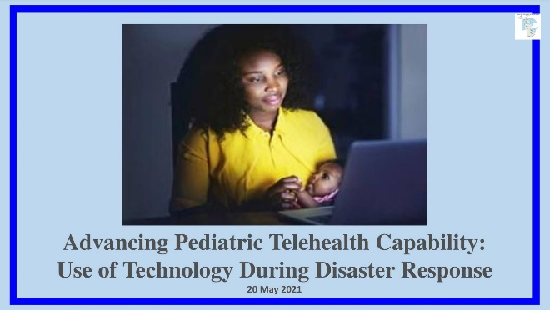 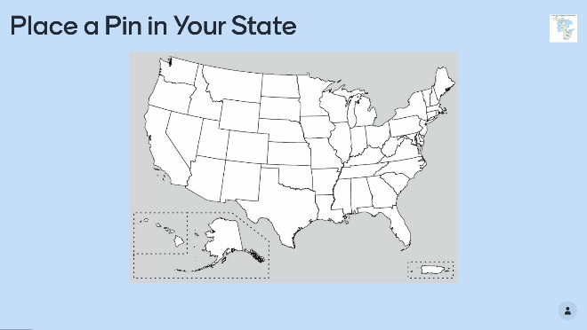

 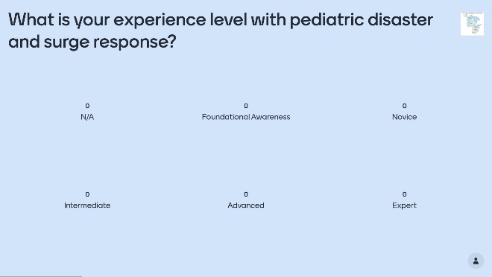

 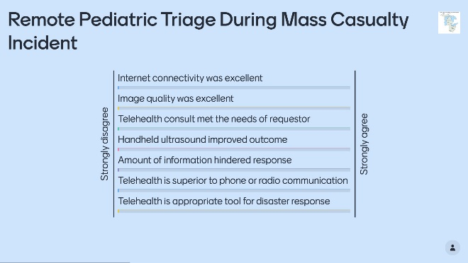

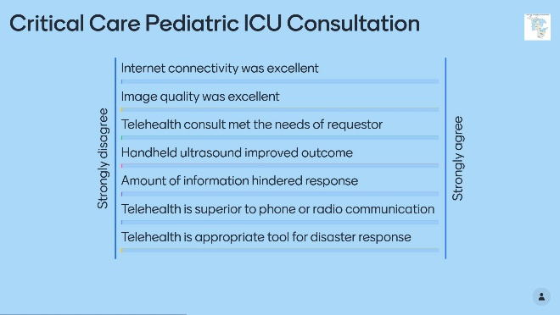 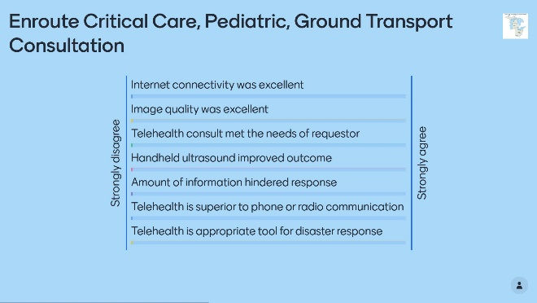

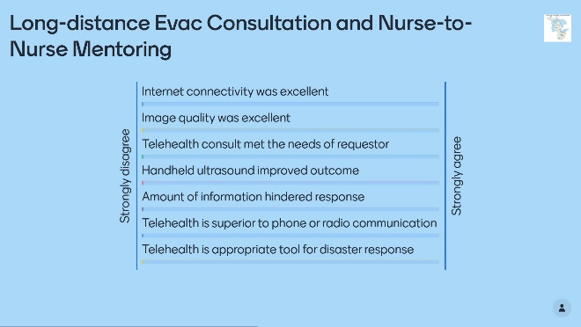 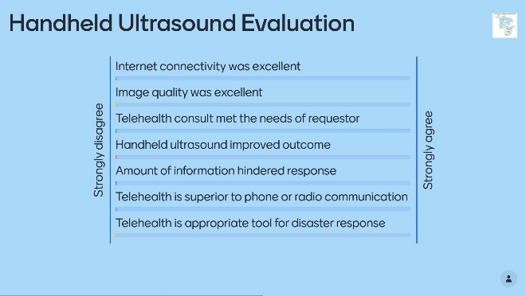

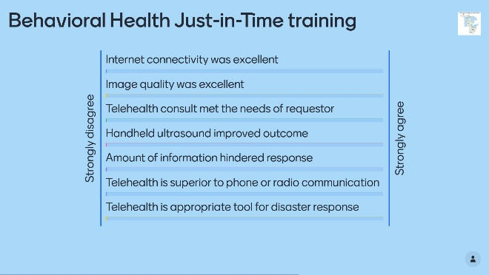 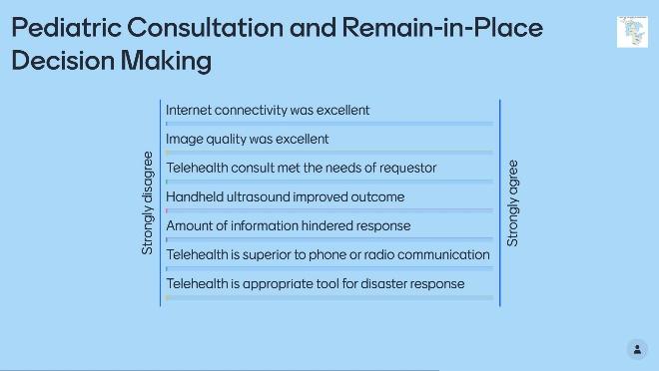

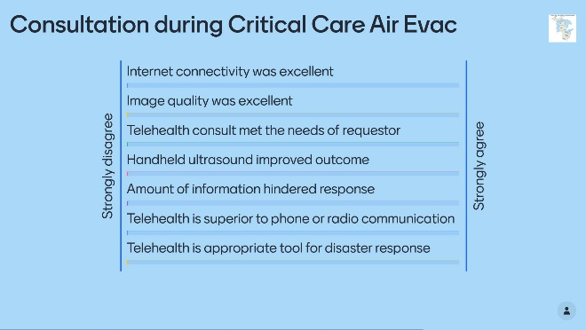 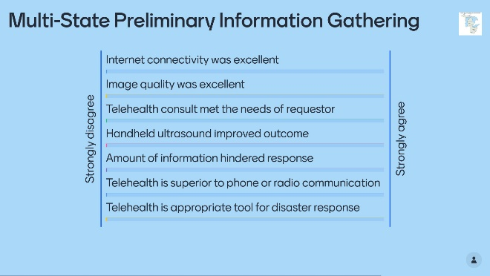

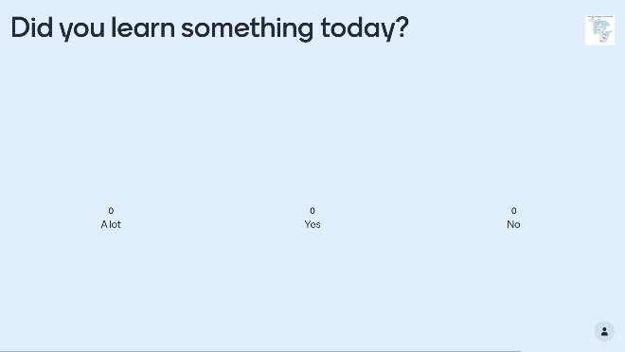 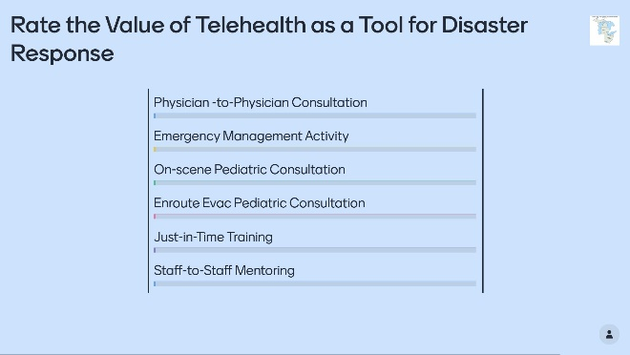

# Appendix D: Post-Exercise Survey

This Post-exercise Survey is designed to collect your perceptions and experience of using telehealth as a tool for pediatric disaster response based upon the Advancing Capability exercise on 20 May 2021.  You will be asked to complete 3 sections:

1) Administrative and Background Information

2) Aspects of telemedicine, and

3) Exercise outcomes.

The survey will take approximately 3 minutes to complete.

Thank you for your participation in this survey.

Section 1 - Administrative and Background Information -Personal information is collected only for the purposes of linking a participant's response across several surveys used throughout the exercise.  Personal information will not be used to contact participants or included in any reports or publications.

Administrative Information

o Name of your organization

o First Name

o Last Name

o E-mail address (Please use the same e-mail used to register for this exercise)

Section 2 - Telemedicine aspects of the telehealth task

o Please rate the following statements:



o Which of the following is your preferred device to use while conducting telehealth activity? (Select one)

Telehealth cart

Desktop PC

Mac or Laptop

Tablet (non-Apple product)

iPhone

iPad Mini

iPad Pro

iPad

Other

o Please rate the following statements:



o Please rate the following statement:



o Please rate the following statement:



o Please rate the following statements:



o Do you have or know of any telehealth innovations that will be useful for pediatric disaster response?  (Answer in free text)

Section 3 - Exercise Outcome

o How much did you learn about the following topics during the Advancing Capability exercise on 20 May 2021?

NothingNot Much - 1-2 new facts or lessons

A Moderate Amount - 2-3 new facts or lessons

Much - 3-5 new facts or lessons

A Great Deal - more then 5 facts or lessons



o How do you rate your proficiency in the following areas?-

N/A (Not applicable to your position)

Foundational Awareness (Basic Knowledge)

Novice (Limited experience)

Intermediate (Practical application)

Advanced (Applied theory)

Expert (Recognized Authority)



o How technically challenging was the requirement to provide a pre-recorded video of a telehealth task?

Easy, no problems

Encountered a problem that was easy to resolve

Neutral

Encountered a problem that was difficult to resolve

Too difficult

N/A

o If applicable, Do you have any additional comments on your experience of producing a pre-recorded video of a telehealth task?

o Please rate the usefulness of the following features of the exercise



# Appendix E: Acronyms

# 