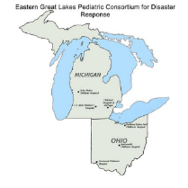
Advancing Pediatric Telehealth Capability:
Use of Technology During Disaster Response

Eastern Great Lakes Pediatric Consortium for Disaster Response
Demonstration Exercise
20 May 2021

Links
Exercise Website: Advancing Capability website (link)
Exercise Contact AdvancingCapability@umich.edu (email)
Exercise Videoconference: Advancing Capability (Zoom link) Passcode: 707747
or dial 312 626 6799, ID: 950 9244 3767, Passcode: 707747

Surveys: Pre-Exercise Survey (link)
Video Production Survey (link)
Post-Exercise Survey (link)

MentiMeter: Menti.com Use code 8379 4994
Or use presentation link (link)
Or QR Code
Mentimeter is an interactive, live-polling presentation platform for
participants to respond to questions and see immediate results
during the exercise.

