EMSC Fellows Program Reference Guide
Thank you for your interest in participating in the Health Resources and Services Administration -Emergency Medical Services for Children (HRSA-EMSC) Program to decrease pediatric morbidity and mortality due to severe illness and injury. The EMSC Program was initially authorized by Congress in 1984. Since then the HRSA-EMSC Program has grown awareness, tools and partnerships to drive improvements in pediatric emergency care delivery across the nation. Each of the six arms of HRSA-EMSC plays a distinct role within and across the emergency care landscape; together they have led to a significant transformation in pediatric emergency care. The pillars of HRSA-EMSC include: 1) Workforce infrastructure, 2) Improvement science, 3) Evidence generation, 4) Accountability, 5) Systems integration, and 6) Innovation.

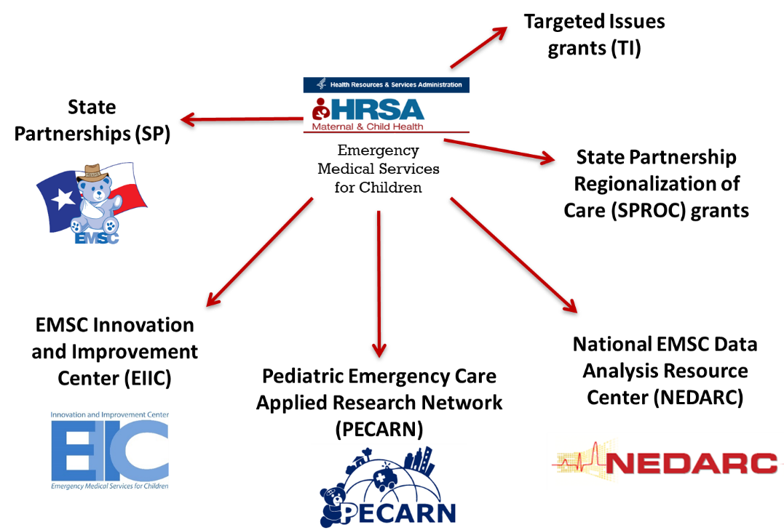

Within the EMSC space, the EMSC Innovation and Improvement Center (EIIC) provides other EMSC grantees and the larger emergency care community with training, support and tools to improve pediatric readiness of emergency care systems across the continuum of care, curates evidenced-based pediatric emergency care resources, leverages quality improvement methodology to minimize morbidity and mortality in children, and utilizes a systems-based approach to align priorities and efforts across diverse organizations.
In an effort to grow future leaders within the EMSC space, the EIIC offers two opportunities to engage early career clinicians and health systems trainees. All clinicians (i.e. emergency medical technicians, paramedics, nurse, advanced practice providers, physicians) and graduate students or early career faculty within related fields (e.g. health policy, healthcare administration, and public health) are encouraged to apply.
- EMSC Scholars Program: designed to support early career (<5yrs post-training) clinicians and health-systems professionals to become future leaders in the EMSC space. During this 1-2 year program, EMSC Scholars will work alongside EIIC leaders to develop and implement a unique project focused on a key area(s) of interest. EMSC Scholars’ projects cross two or more areas of interest including advocacy, knowledge translation, knowledge dissemination, marketing and communications, prehospital pediatric readiness, pediatric readiness of emergency departments, quality improvement methodology, analytics, workforce development, health policy, healthcare administration, research, and value-based care. Appointments: 1-2 years, Time commitment: 2-4 hours/week.
- EMSC Fellows Program: designed to support trainees and early career professionals with an opportunity to engage in EIIC-led efforts to better understand systems-based strategies for improvement. Fellows are invited to serve on national steering committees to better understand the work of EMSC stakeholders. Fellows will be assigned to a single area of focus and one or more EIIC mentors who will provide ongoing support and opportunities for participation. Appointments: 1-2 years, Time commitment: 2-4 hours per month, participation in steering committee meetings and associated activities.

Timeline
Applications open: November 18, 2020
Applications due: January 15, 2021 @ 11:59 PM CT
Notification of Acceptance: February 15, 2021

General Application
In order to streamline the application process, we have created a general application process for all open Fellow positions in this cycle of applications. To apply for an EMSC Fellows Program position, complete the application here.
Applicant Information
Applicants will be asked to complete sections for their name, credentials, email, title,
institution/ organization, city and state.
General Application
Applicants will be asked to select which EMSC Program they are applying for. After selecting
“EMSC Fellows Program”, you will be prompted to upload your CV and Letter of Interest. It is
recommended that the Letter of Interest should not exceed 1 page. Despite selecting multiple
areas of interest, please only submit one general Letter of Interest.
Areas of Interest
In order to ensure appropriate resources and support, we ask that each applicant identify their
order of preference for up to 3 areas of interest. If you are only interested in 1 or 2 of the areas
of interest, select the “None” option for the corresponding question(s). For more information
about the areas, please visit our website here:

- Advocacy
Leaders at the Child Health Policy and Advocacy Center at University Hospitals/Rainbow Babies work collaboratively with the EMSC Family Advisory Network to support community engagement, state and national initiatives, and increase awareness of pediatric emergency care needs and healthcare disparities, all the while, placing patients and families at the heart of our work.
- Collaboratives
The EMSC Innovation and Improvement Center is spearheading a QI collaborative to assist state programs in accelerating their progress in improving the pediatric readiness of EDs and to develop a program to recognize EDs in their state that are ready to care for children with medical emergencies. State improvement teams will benefit by interacting with experts in both pediatric readiness and facility recognition, as well as a cadre of QI specialists.
- Hospital-Based Care
Much of the Hospital Based Care work carried out at the EIIC is currently focused on the National Pediatric Readiness Project and other Quality Improvement Collaboratives. The National Pediatric Readiness Project is a multi-phase quality improvement initiative to ensure that all U.S. emergency departments have the essential guidelines and resources in place to provide effective emergency care to children.
- Knowledge Management
The Knowledge Management domain’s mission is to deliver knowledge and evidence-based science in a variety of formats (webinars, podcasts, videos, learning modules, simulation cases, infographics, etc.) and to create a dynamic and comprehensive central home for knowledge synthesis, content creation and curation, and content dissemination. The KM domain seeks to deliver the latest knowledge in diverse formats to match each EMSC target-audience’s needs: 1) scientific community (clinicians and researchers), 2) EMSC stakeholders, 3) advocates, and 4) the public.
- State Partnership
The SP Program aims to establish a universal presence across all 59 U.S. states and jurisdictions to ensure that children receive optimal emergency care no matter where they live or travel. Each state and jurisdiction works to improve the same prehospital and hospital performance measures, representing the largest national effort to standardize pediatric emergency care.
- Trauma
The EIIC trauma domain seeks to support EMSC grantees and stakeholders in providing resources to optimize pediatric trauma care. This is accomplished by identifying and disseminating best practice evidence based pediatric trauma care guidelines while encouraging the development of needed essential guidelines for the care of all injured children.

Letter of Recommendation
Applicants will be asked to have one Letter of Recommendation submitted to fulfill this requirement of the application. In acknowledgement that many individuals writing a Letter of
Recommendation would like to submit without the applicant reading the letter, we are asking
applicants to submit the name, title and email of the individual who will be writing the Letter of
Recommendation. Please have the individual writing your Letter of Recommendation email it to
Wrandi Carter, MPH (wrandi.carter@austin.utexas.edu) with the subject heading “EMSC
Fellows Program Letter of Recommendation – Applicant Name”. Applicants will be notified
once a Letter of Recommendation is received on their behalf.

The deadline to apply for the EMSC Fellows Program is January 15, 2021 at 11:59 PM CT.

Notification of acceptance emails will be sent out no later than February 15, 2021.

If you have any questions or concerns, please reach out to Wrandi Carter, MPH at wrandi.carter@austin.utexas.edu.

