EMSC Scholars Programs Reference Guide
Thank you for your interest in participating in the Health Resources and Services Administration -Emergency Medical Services for Children (HRSA-EMSC) Program to decrease pediatric morbidity and mortality due to severe illness and injury. The EMSC Program was initially authorized by Congress in 1984. Since then the HRSA-EMSC Program has grown awareness, tools and partnerships to drive improvements in pediatric emergency care delivery across the nation. Each of the six arms of HRSA-EMSC plays a distinct role within and across the emergency care landscape; together they have led to a significant transformation in pediatric emergency care. The pillars of HRSA-EMSC include: 1) Workforce infrastructure, 2) Improvement science, 3) Evidence generation, 4) Accountability, 5) Systems integration, and 6) Innovation.

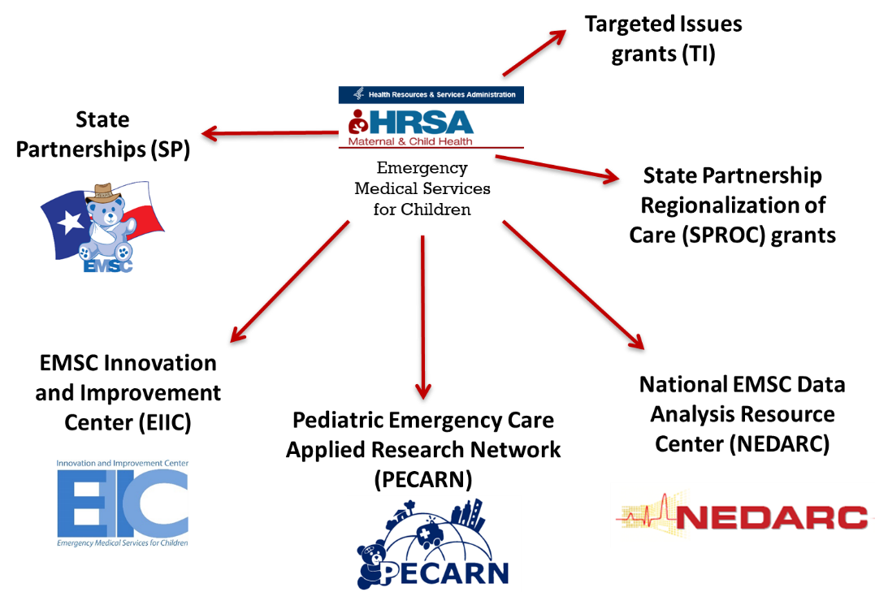

Within the EMSC space, the EMSC Innovation and Improvement Center (EIIC) provides other EMSC grantees and the larger emergency care community with training, support and tools to improve pediatric readiness of emergency care systems across the continuum of care, curates evidenced-based pediatric emergency care resources, leverages quality improvement methodology to minimize morbidity and mortality in children, and utilizes a systems-based approach to align priorities and efforts across diverse organizations.
In an effort to grow future leaders within the EMSC space, the EIIC offers two opportunities to engage early career clinicians and health systems trainees. All clinicians (i.e. emergency medical technicians, paramedics, nurse, advanced practice providers, physicians) and graduate students or early career faculty within related fields (e.g. health policy, healthcare administration, and public health) are encouraged to apply.
- EMSC Scholars Program: designed to support early career (<5yrs post-training) clinicians and health-systems professionals to become future leaders in the EMSC space. During this 1-2 year program, EMSC Scholars will work alongside EIIC leaders to develop and implement a unique project focused on a key area(s) of interest. EMSC Scholars’ projects cross two or more areas of interest including advocacy, knowledge translation, knowledge dissemination, marketing and communications, prehospital pediatric readiness, pediatric readiness of emergency departments, quality improvement methodology, analytics, workforce development, health policy, healthcare administration, research, and value-based care. Appointments: 1-2 years, Time commitment: 2-4 hours/week.
- EMSC Fellows Program: designed to support trainees and early career professionals with an opportunity to engage in EIIC-led efforts to better understand systems-based strategies for improvement. Fellows are invited to serve on national steering committees to better understand the work of EMSC stakeholders. Fellows will be assigned to a single area of focus and one or more EIIC mentors who will provide ongoing support and opportunities for participation. Appointments: 1-2 years, Time commitment: 2-4 hours per month, participation in steering committee meetings and associated activities.

Timeline
Applications open: November 18, 2020
Applications due: January 15, 2021 @ 11:59 PM CT
Notification of Acceptance: February 15, 2021
EMSC Scholars Program Orientation: February 22, 2021 @ 10 – 11:30 PM CT

General Application
In order to streamline the application process, we have created a general application process for all open EMSC Scholars positions in this cycle of applications. To apply for an EMSC Scholars Program position, complete the application here.
Applicant Information
In this section you will be asked to complete sections for your name, credentials, email, title,
institution/ organization, city, and state.
General Application
Applicants will be asked to select which EMSC Program they are applying for. After selecting
“EMSC Scholars Program”, you will be prompted to upload your CV, Letter of Interest, and a
sample of your work. It is recommended that the Letter of Interest should not exceed 2 pages.
Work products can include but are not limited to abstracts, conference presentations,
educational interventions, advocacy campaigns, social media campaigns, blogs, or programs
you’ve developed. Despite selecting multiple areas of interest, please only submit one general
Letter of Interest.

Areas of Interest
Scholars will be expected to work with EIIC leaders to develop a unique project of interest.
Projects are intended to be cross-cutting and may involve more than 3 areas; however, in order
to ensure appropriate resources and support we ask that each applicant identify their top 3
areas of interest. For more information about the areas of interest, please see below or visit our website here:
- Advocacy
Leaders at the Child Health Policy and Advocacy Center at University Hospitals/Rainbow Babies work collaboratively with the EMSC Family Advisory Network to support community engagement, state and national initiatives, and increase awareness of pediatric emergency care needs and healthcare disparities, all the while, placing patients and families at the heart of our work.
- Analytics
The Analytics core drives the development of data management systems to support and measure engagement, progress, and dissemination across our nation’s emergency care landscape. Innovative, user-driven designs steeped in quality improvement methodology are at the core of our efforts.
- Healthcare Administration
The EMS for Children Innovation and Improvement Center works collaboratively with leading national professional societies to develop leadership in pediatric emergency care and oversight of system processes to minimize risk.
- Health Policy
The EMS for Children Innovation and Improvement Center has long-standing relationships with national professional organizations who work tirelessly to bridge gaps in advocacy and policy development to foster equity in pediatric emergency care delivery.
- Knowledge Dissemination
Using multi-modalities including scientific presentations, publications, innovative digital platforms, podcasts, and social media, leaders of the EIIC’s dissemination efforts are seeking new and expansive ways to engage the larger emergency care workforce to meet the emergency care needs of children.
- Knowledge Translation
Together with national and international partners, knowledge translation leaders operationalize evidence-derived content into clinical decision support and systems design tools. Well-researched and vetted Pediatric Emergency and Advocacy Kits (PEAK) support the rapid uptake and adoption of outcomes-based practice.
- Marketing and Communications
Communication is at the core of the EMS for Children Innovation and Improvement Center linking the six arm of HRSA EMSC as well as bridging and coordinating efforts across federal entities and professional societies. Leaders use multiple modalities, novel conceptual frameworks, and visualization tools to engage current and future partners.
- Pediatric Readiness of Emergency Departments
Each year the majority (>15M) of children seek emergency care in emergency departments that often lack essential resources to meet the needs of critically ill and/or injured children. In the absence of universal standards for licensing or accreditation, we help guide efforts to identify and overcome gaps in pediatric emergency care delivery.
- Prehospital Pediatric Readiness
Children account for ~10% of all EMS transports, yet EMS providers often receive limited initial and ongoing pediatric training. Working within EMS systems that were initially designed to primarily meet the needs of adults, the EMS for Children Innovation and Improvement Center works collaboratively with national partners to develop strategies, resources, and opportunities to improve prehospital emergency care delivery.
- Quality Improvement Methodology
Quality improvement science has led to more rapid transformation in healthcare (3-5yrs) than passive uptake of published research thereby shortening time from evidence generation to practice. Through national quality improvement collaboratives that engage a wide range of stakeholders, the EMS for Children Innovation and Improvement Center seeks to drive broad system-level change in pediatric emergency care delivery.
- Research
The EMS for Children Innovation and Improvement Center Research core seeks to create knowledge and accelerate its journey to implementation by working closely with the Pediatric Emergency Care Applied Research Network (PECARN) and EMS for Children Targeted Issues grantees to identify and address priority areas in pediatric emergency care.
- Value-Based Care
The triple aim of healthcare includes not just improved health outcomes and patient experience but also minimization of cost. Working from the premise that healthcare value equates to quality over cost, we seek to develop models for return on investment that can drive changes to healthcare policy and system design.
- Workforce Development
Given that children represent only a minority (20%) of all emergency care visits, transformation of the pediatric emergency care experience can only occur on the shoulders of knowledgeable, dedicated, and vocal champions who work collaboratively to inform and effect change. The EMS for Children Innovation and Improvement Center sees the pediatric healthcare workforce as a top priority in our mission to achieve healthcare equity.

Letter of Recommendation
Applicants will be asked to have one Letter of Recommendation submitted to fulfill this requirement of the application. In acknowledgement that many individuals writing a Letter of Recommendation would like to submit without the applicant reading the letter, we are asking applicants to submit the name, title and email of the individual who will be writing the Letter of Recommendation. Please have the individual writing your Letter of Recommendation email it to Wrandi Carter, MPH (wrandi.carter@austin.utexas.edu) with the subject heading “EMSC Scholars Program Letter of Recommendation – Applicant Name”. Applicants will be notified once a Letter of Recommendation is received on their behalf.

The deadline to apply for the EMSC Scholars Program is January 15, 2021 at 11:59 PM CT.

Notification of acceptance emails will be sent out no later than February 15, 2021.

If you have any questions or concerns, please reach out to Wrandi Carter, MPH at wrandi.carter@austin.utexas.edu.

